Generic Terms of Reference
Assignment Title: | Project/Component/Intervention Preparation for Fecal Sludge Management Service Provision
Location: | Xxx
Assignment Duration: | xxx days
Assignment Type: | Firm
International/Local: | Xxx

Background
Provide a description and context of the project

Acronyms
CAPEX | Capital expenditure
CBO | Community-based organization
FGD | Focus group discussion
FS | Fecal sludge
FSM | Fecal sludge management
FSTP | Fecal sludge treatment plant
KII | Key-informant interview
M&E | Monitoring and evaluation
NGO | Non-governmental organization
O&M | Operation and maintenance
OPEX | Operating expenditure
PPE | Personal protective equipment
PSP | Private sector participation
SFD | Fecal sludge flow diagram
TOR | Terms of Reference
TS | Transfer station

Objectives
The overall objective of this assignment is to prepare a fecal sludge management (FSM) investment project/component/intervention in XXX by looking at the related institutional, technical, financial, business development, customer acceptability and sanitation marketing dimensions. The key sub-objectives of this assignment are listed immediately below. The methodology employed to achieve these objectives draws on the use of qualitative and quantitative data collected from primary and secondary sources such as: key informant interviews with government officials and service providers; focus group discussions with a range of stakeholders; household interview data; observational site visits; service provider records; and government/non-governmental/other reports and assessments. The sub-objectives of this assignment are to:
- Assess and analyze the current FSM system in XXX, with a focus on the quality of the existing FSM services and the existing FSM market (if these exist), identifying the hurdles, gaps and bottlenecks to providing improved FSM service delivery. The assessment should explore why failures exist. This should include an assessment of the sector context at the country level and in the urban center/s in which the FSM intervention is proposed. These assessments should consider institutional and implementation arrangements (including the regulatory framework and the role of private sector participation), to reflect the existing service models that have often emerged without planned government intervention (through the informal/formal private sector and/or through NGOs, for example). These FSM assessments should adopt a citywide sanitation and poor-inclusive approach and should consider the following aspects: institutional arrangements; the policy and regulatory frameworks, the technical elements of the system, the funding/financial arrangements, social dimensions such as customer perceptions, satisfaction and engagement, and environmental considerations.
- Propose solutions (for the short term, XX years, and the medium term, YY years) to the hurdles identified while considering the policy, regulatory and institutional arrangements, the technical elements, the funding/financial arrangements, user/customer perceptions and environmental dimensions.
- Develop standard Bills of Quantities and Technical Specifications for the purchase of the necessary equipment and the design of the relevant infrastructure, such as fecal sludge (FS) transfer stations (TS) and FS treatment facilities.
- Develop an institutional strengthening/transformation plan and associated investments including organogram/s, staffing roles/responsibilities, capacity building plans, systems development (software and hardware), and the preparation of a procedures/operations manual to improve the management of FSM along the full service chain.

The assessments, and the resulting Bills of Quantities and Technical Specifications, should consider all the steps in the sanitation service chain, including the capture/containment, emptying, conveyance, treatment, and end use/safe disposal of the fecal sludge.

Scope of Work
The Consultant/Firm will undertake the following activities, using secondary data sources where available, but supplemented by key informant interviews, household interviews or surveys, focus group discussions and field visits to verify/ground-truth the data gathered from the secondary sources. The Consultant/Firm will work closely with the appointed Government counterparts and prepare a draft report summarizing these activities, and will present the work at, and participate in, a series of stakeholder workshops to discuss different aspects of the work, to be organized by the Government project team. It is expected that the Consultant/Firm will work in close consultation and coordination with the Government counterparts to ensure their effective engagement with, and awareness of, the activities undertaken with regards to these Terms of Reference (TOR).

The Consultant/Firm shall provide a team of individuals with adequate profiles to cover the necessary policy, regulatory, institutional, financial, business planning, technical, social and environmental aspects of the assignment. To complement these TOR, we recommend drawing on the resources listed in Annex 1, which provide further details on the design and operation of FSM systems. Also, all map products shall be prepared using the same or compatible base maps and software as those used by the government client.

Assessment of Current System

Institutions
- Map all existing formal and informal stakeholders involved in: (i) sanitation service provision (by government (national and local level), the private sector, informal sector, NGOs, CBOs, etc.); (ii) the regulation of sanitation service provision; and (iii) the users/recipients/customers of sanitation services;
- Arrange and conduct key informant interviews (KIIs), and/or focus group discussions (FGDs), as appropriate, with individuals from stakeholder institutions selected in consultation with the Government project team, and produce notes and/or transcripts of each discussion/meeting. These interviews/discussions are aimed at identifying: (i) the institutional perspective on the status (current practices and issues) of FSM; (ii) knowledge/awareness of stakeholders regarding FSM; (iii) the relative importance/prioritization of FSM, currently and in the future: (iv) the social, environmental, public health, financial and related impacts of current FSM practices and of the related enabling environment. Information should also be collected related to any proposed developments/improvements in sanitation service provision generally and with regard to FSM services in particular, included any related business plans that might be under development/implementation;
- Collect all relevant documents and other secondary data referred to by the interviewees in the KIIs/FGDs, such as policy documents, financing frameworks, business plans, etc.;
- Using a Political Economy Analysis assess the current formal and informal framework, and the responsibilities and capacities of the involved institutions, while highlighting gaps, constraints and issues within the current institutional set up and proposing amendments to the existing FSM service delivery system. The relationships between the different stakeholders, as well as the efforts made to date by each of them to try to work together, should be noted;
- Assess the current regulatory framework to identify: (i) current institutional responsibilities and oversight agencies; (ii) existing regulations and the extent to which regulations are enforced, noting accountability mechanisms, if any; and (iii) any apparent regulatory gaps, constraints and issues in the current and planned FSM service delivery system;
- Assess the capacity of the formal public sector, the formal private sector and informal actors currently involved, and with the potential for being involved, in FSM service delivery, with a focus on their institutional structures and the general resources and human resources at their disposal, while considering both the current FSM system and any proposed upgrades, extensions and/or changes to the existing FSM system.

Technical
- Evaluate the technical aspects of the existing fecal sludge service chain, considering all relevant dimensions. Annex 3 provides additional details of the types of information that should be collected;
- Estimate the present day and the projected quantities and quality of sludge along the sanitation service chain (considering both fecal sludge/septage from domestic sources and from institutional, commercial and industrial sources), establishing the proportion that is safely managed and the existing demand for FSM services. Estimate enhancements that could be achieved with containment improvements and how this would affect sludge quantity and quality, as well as the likely increase in quantities, and changes in quality, on account of introducing more regular desludging. If it does not already exist, consider preparing a Fecal Waste Flow Diagram (SFD) for discussion with stakeholders. This data will help to illustrate where in the sanitation chain improvements are most needed;
- Assess the technical gaps, constraints and needs within the existing FS service chain including the demand for fecal sludge/septage collection and treatment, and the corresponding quality and capacity characteristics/parameters of the different elements in the FSM chain, including the transportation, FS transfer stations (if relevant), and fecal sludge/septage treatment plant/s;
- Identify whether any illegal/informal dumping of fecal sludge is occurring, where this is occurring, the frequency and volumes involved, and the resulting environmental and public health impacts;
- Review the hydrogeological, meteorological, land-use and topographical situation in the defined area and assess how the situation may influence the type of FS service delivery/technologies that can be provided;
- Consider disaster risk reductions and climate change adaptations needed for safely managed sanitation, based on the projected climate impacts in the city;
- Gather and evaulate input from the target communities on their degree of satisfaction with the existing FS technologies and service provision and identify what improvements/changes could be made;
- Evaluate working conditions of sanitation workers, specifically from occupational hazards ranging from chemical, physical and microbial, and the use of personal protective equipment (PPE) to maintain safely managed sanitary conditions;
- Assess the status of relevant complementary urban services, including: road access, solid waste management, storm- and graywater management, and water supply (including quality and quantity of each service, where relevant), focusing on how these sectors affect access to and use, control and sustainability of, existing and proposed FS service delivery;
- Carry out a review of sanitation technology pilots/innovations in the same or comparable cities that have been previously tried and provide a review of their successes/lesson learned from failures. Where ‘Container-based sanitation’ services exist, assess whether there is a desire to scale them up;
- Assess the demand for the treated/untreated end products from FSM, specifying at what part of chain the products are demanded and whether the products are safe for their respective end uses. Consider the match between supply and demand of reuse products, including seasonal variations in both, and identify gaps, constraints and issues with the current and proposed end use plans;
- Explore a range of possible appropriate technologies for use across the full sanitation service chain. Partnerships with local academic institutions, utilities and/or engineering companies should be considered in a bid to develop locally appropriate and maintainable emptying, transfer and treatment technologies. Share these possible options with the Government project team to receive feedback on the advantages and disadvantages of the different options. Any impacts on the technology selection of the World Bank’s Environmental and Social Safeguards Framework should be considered and appropriately detailed, such as implications regarding gender and vulnerable groups.

Funding/Financial Arrangements
- Describe the existing funding/financial framework for FS service delivery (along the full service chain) in the area/s being assessed, including the capital costs (CAPEX) and the running/operation and maintenance costs (OPEX), cost recovery mechanisms, payment systems (how are payments made; who pays; amount and frequency; collection mechanisms; financial management of the payment systems; etc.), current costs faced by households (split by what fees they face for CAPEX and OPEX for each stage of the service chain), customers’ willingness and ability to pay, payment enforcement mechanisms, existing government budget allocations for investment costs and for running costs;
- Assess private investors and commercial banks (including microfinance entities) willingness/interest/ability to invest in the sanitation sector generally and in the FSM sanitation service chain in particular, and the conditions for investment (e.g., payback period, return on investment, risk management, policy and regulatory environment to attract private financing, client acceptability, revenue source acceptability, economies of scale and contiguity, etc.). Identify the possibility of having private involvement in operations, such as through management contracts, design-build-operate (DBO) contracts, etc., to undertake desludging, to operate and maintain transfer stations and treatment plants, to undertake reuse, etc. Together with the institutional specialist, identify the current regulations regarding private sector participation (including for public-private-partnerships) in the sanitation sector;
- Identify apparent gaps, constraints and issues within the existing financial framework for sanitation service delivery, including all forms of sanitation services, (including cost recovery mechanisms, systems of payment, management of payment, ability to pay, enforcement of payment, types of investors, use of revolving funds/subsidy from government, etc.);
- Explore a range of possible funding/financing models that may be appropriate for covering CAPEX and OPEX for the full sanitation service chain. Share these possible options with the Government project team to receive feedback on advantages and disadvantages of the different options. Any impacts by the business models on the World Bank’s Environmental and Social Safeguards Framework should be considered and appropriately detailed.

Business Development
- Assess the current formal and informal business models being used for the delivery of services across the full sanitation service chain, with a focus on business models relevant to FSM service delivery;
- Assess the posibility to improve the current business models, in order to allow for quicker uptake and retention by service providers, including the development of possible synergies with other local services (water supply, solid waste collection, etc.);
- Assess what would be required for the current models to become more financially viable;
- Explore a range of possible business models (including innovations in comparable cities) to be used for the delivery of FSM services across the full sanitation service chain (see Annex 2 for some examples). Share these options with the Government project team to receive feedback on their advantages and disadvantages. Look for synergies/economies of scope and scale in FSM service delivery with other local services such as sewerage, water supply, solid waste management, drainage management, etc. Any impacts by the business models on the World Bank’s Environmental and Social Safeguards Framework should be considered and appropriately detailed.

Customer Acceptability and Sanitation Marketing
- Assess the current practices, behaviors and views of existing FSM customers, including their demand for services and their attitude to, satisfaction with, and perceptions of the existing FS service options. Identify household drivers of interest in and willingness to pay for improved services, as well as feasible payment mechanisms including their preference for ‘on demand’/as needed payment or regular smaller payment schedules;
- Summarize existing information/material/approaches on tackling open defecation and/or other inappropriate behaviors, as well as any sanitation behavior change/awareness raising programs, and suggest ways to include such approaches in the package of recommended improvements;
- Summarize existing material used for sanitation marketing, communication and hygiene promotion, including who developed the material, how successful the promotion has been, and any lessons learned;
- Explore the potential for the use of “mobile-to-web” technology platforms that (i) the government can use to develop an inventory, map assets, monitor sanitation services, etc., and/or (ii) customers can use to request services from emptiers via their cell phones, lodge complaints, pay bills, receive information from service providers on service provision issues and resolutions, etc.

The assessment of the current systems, including institutional, technical, financial, business development and customer acceptability dimensions, should be used to develop a baseline against which the project/component/investment progress can be assessed.

Design and Implementation of Improvements

Institutions
- With input from the government counterparts and other stakeholders, from the technical specialist and from the household surveys/focus group discussions/key informant interviews, propose relevant legal, policy, regulatory and organizational changes required to achieve improved FSM service delivery and FSM public/private market development. Develop a budget for the costs of the associated institutional development/improvements (including capacity building, design and implementation of new management systems, contractual arrangements, regulatory and monitoring systems, etc.). For this work, consider, a range of FSM service delivery models including management models. Some examples of service delivery models include:
  - A private sector or franchise arrangement for containment provision;
  - A franchise approach where larger operators such as vacuum tank operators would manage a group of fecal sludge treatment plants (FSTPs) and transfer stations (TSs) and the associated pit emptying micro-enterprises (e.g., small scale mechanical emptiers and manual emptiers);
  - A model in which the water and sanitation utility/service provider contracts out and oversees the services of large FS emptiers/conveyors and, through them, micro-enterprises, and in which the utility manages the FSTPs and TSs;
  - A model in which a regulatory agency regulates the activities of existing FS service providers and micro-enterprises, with a ‘free for all’ market model across the city or with pre-identified neighborhood concessions/franchises;
  - A mixed model where the responsible agency continues to operate vacuum tankers, TSs and the treatment facilities, alongside private sector involvement in emptying and conveyance;
  - Autonomous emptiers and PPPs for TSs and FSTPs;
  - Public sector provision of services;
  - Private sector operation and maintenance of systems.
The suitability of each model to the context under assessment should be detailed, drawing in particular on examples of where such approaches have previously worked. The proposal should define under what circumstances selected examples worked and at what scale, how these examples relate to the country/city in question, and how sustainable the model is without donor funding (in order to determine the risks to service provision and what human capacity development is required to maintain the services under the model in question following the eventual withdrawal of donor funding).
- With input from the technical specialist, develop and provide cost estimates for advocacy programs (if required) and capacity building programs for the service providers that consider global good practices in FSM service delivery. Where required/deemed appropriate, enforcement and/or incentive structures should be detailed for improved FSM service delivery;
- With stakeholder involvement discuss, make suggestions on the content of, and draft the necessary documents (terms of reference (TOR), licenses, leases, service contracts, regulatory protocols, etc.) for the proposed FSM system, and propose any other government-led requirements or changes, such as the promotion of or changes to existing regulations and policies, that may need to occur;
- With input from the technical specialist, develop costing plans (including any necessary TORs and related materials) for the required stakeholder development, training by the government of service providers (private or public) and marketing of new service delivery options to consumers.

Technical
- Identify the most viable/appropriate infrastructure/hardware interventions along the sanitation service chain, including the containment structures, emptying equipment, any transfer stations, the treatment plants and the reuse facilities (their numbers, types, dimensions, locations, construction/material details, specialized design requirements to address situational constraints, user acceptability, lifespan, cost efficiency (to both customer and utility), operational and maintenance (O&M) requirements) to ensure the FS is safely managed along the sanitation chain and meets the relevant regulatory standards – including the following aspects:
  - Identify suitable household containment options, which may include the construction/provision of new systems and/or the retrofitting of existing facilities;
  - Estimate the demand (by different areas within the city) for vacuum tanker and non-vacuum tanker sludge emptying services, and show the evolution of this demand over time. Propose the numbers and locations of FS treatment plant/s and transfer station/s, based on a balance of the demand for services (both current and projected), economies of scale (centralized or decentralized systems), the travel distances for the emptiers and the associated costs to them, and land availability for the construction of TSs and FSTPs. The use of modular construction methods for TSs and FSTPs may be appropriate to align with demand and growth predictions. The logistical optimization of FS transportation and treatment should also consider (i) co-treatment facilities in existing wastewater treatment plants; and (ii) facilities to allow for the discharge of FS into existing sewer networks/sewage pumping stations, as appropriate;
  - Undertake a technical optimization of the sizes of the FSTPs and the TSs in the system based on the quantification and characterization of FS, the demand for emptying services (both current and projected) and the sizes/designs of the containment structures and of the emptying equipment. Consideration should also be paid to end-use volume demands and the implications for end-use storage, transfer and related facilities;
  - Identify the existing FSTPs and TSs, including any wastewater treatment plants where co-treatment may be occurring, assess their performance, and identify the needs for their retrofitting, upgrading or for increasing their capacity in order to accommodate the expected increase in FS loading;
  - Prioritize the FSTP and TS locations considering land availability, electricity supply (where this is required for system functioning), service area coverage, future demand etc., with a preference for options which minimize travel time (considering the distance and the speed of the different transportation equipment currently employed and/or recommended). This analysis should compare the associated costs of centralized and/or decentralized FSTPs and TSs. The use of mobile transfer stations should also be considered;
  - Describe the type, quantity, frequency and quality of current and potential future end-use materials for which there is, or could be, market demand. Quantify, to the extent possible, the anticipated willingness to pay for these products (based on the sale of similar existing products in the market). Reuse options should be assessed (financially, institutionally, technically, socially and environmentally) against the alternative of disposal. Appropriate monitoring options to analyse the safety of FS for reuse or for disposal should be detailed;
  - Incorporate into the operation and maintenance (O&M) requirements an appropriate monitoring and evaluation (M&E) framework for use throughout the FSM service chain. Recommend a record keeping protocol for helping improve service delivery, and its management and regulation.
- Estimate the costs of the improved FSM system, including:
  - The CAPEX and OPEX of the emptying equipment associated with/for serving each FSTP and each TS, and that of the emptying equipment to transfer FS from the TSs to the FSTP, and the O&M costs of any emptying related activities, such as post-emptying site clean-up for household and public containment facilities;
  - The CAPEX and OPEX of each TS and FSTP;
  - The CAPEX and OPEX of any co-treatment facilities in existing wastewater treatment plants or for facilities to allow the discharge of FS into existing sewer networks/ sewage pumping stations, if feasible.
- Develop standard Bills of Quantities and Technical Specifications for the procurement of the FSM civil works and equipment packages;
- In collaboration with the institutional specialist, develop the cost plans and the TORs for any necessary technical assistance, technical backup, training and marketing needed to implement the proposed improvements to the FSM system;
- Provide technical design and costing to the institutional specialist and the financial specialist, to assist in developing overarching institutional and financial models for the FSM system;
- In collaboration with all of the other team specialists, develop a monitoring and evaluation (M&E) framework that can be used to assess the success of the FSM service system;
- Together with the institutional specialist, provide options to improve the enforcement and the incentives to encourage the delivery of all of the FS to the treatment plant/s;
- Develop an implementation plan, including targets and details for: (i) how fast the growth in demand for FSM services will occur; (ii) the associated CAPEX and OPEX at each stage of the plan; (iii) the resources (in terms of goods, manpower and financing) needed at each stage; (iv) how existing undesirable practices (such as the inadequate design, construction, operation and maintenance of containment facilities; illegal FS dumping; and manual emptying) can be phased out; (v) how current unsafe practices could be made safe; and (vi) how informal and formal sector actors will be engaged, etc.

Funding/Financial Arrangements
- Identify solutions for the gaps, constraints and issues identified with the existing financial framework for the sanitation service delivery chain, which would help achieve improved FS service delivery;
  - If appropriate, consider economies of scale and economies of scope as well as the requirements for effective private sector participation (PSP) for improved FS service delivery, and propose PSP arrangements (such as franchises, contracts, license agreements) as appropriate;
- In collaboration with the other specialists, develop an M&E framework that can be used to assess the success of the service delivery system;
- Prepare a financing model for the improved FS service delivery system (based on the technical specialist’s findings), showing who will pay for CAPEX and OPEX, including household fees/tariffs, utility contributions, government subsidies, private sector fees, revenues generated from reuse products, etc., and stating how payments may be made and managed.
  - In addition to tariffs, also consider the availability of government transfers and funds raised through municipal, state/regional or national taxes (e.g., sanitation taxes, environmental taxes, property taxes, public health taxes, etc.).
  - When proposing household tariffs, consider what will be subsidized (CAPEX, OPEX, or both), and consider the subsidies across the full sanitation service chain, and how this will impact the target/s of the subsidies (e.g., subsidizing on-site and/or sewer system sanitation users, poor or wealthy households, etc.). The tariff setting process will also need to be in line with government priorities for the sanitation sector and should incorporate global knowledge and good practices in setting tariffs and in establishing subsidies/cross-subsidies.

Business Development
- In collaboration with the other specialists, develop an M&E framework that can be used to assess the success of the service delivery system;
- Recommend specific business models (including possible organizational models for the operators) to be used for service delivery across the full sanitation service chain that will optimize the commercial viability of FSM services (specifically for collection and transportation – but also looking at treatment and reuse) and which may include splitting the city into smaller ‘zones’, if appropriate.

Customer Acceptability and Sanitation Marketing
- Identify actionable ways that customer satisfaction with their FS service delivery can be improved and/or demand can be created, by detailing the steps to be taken to ensure that customers understand the new FS service delivery model and financing plan, including: (i) a customer awareness raising/education program; and (ii) a customer outreach model. All recommended activities should incorporate lessons learnt from the current FS service delivery system, and they should be fully costed and, as appropriate, include TORs to procure the related consulting services (in particular, a TOR for preparing a customer outreach program should be prepared);
- Assess any barriers to access (including behavioral, physical and financial) to FSM services that currently exist for the poorest households with a focus on sub-groups (e.g., tenants of rental housing, housing in challenging environments, people with disabilities, women, ethnic minorities, etc.), and identify key actions – and the associated costs to implement them – in order to ensure the full inclusion of all people with services in the project area;
- Explore financing mechanisms (e.g., revolving funds, microfinance, saving schemes, etc.) for improving household ability to invest in new sanitation infrastructure and/or to improve existing facilities, as well as for them to pay OPEX fees/tariffs, and identify a prioritized list of financing mechanisms to implement, as well as the costs, to the government to support/implement these options, and, as appropriate, prepare TORs for designing and implementing these programs;
- Propose an implementation plan for whichever customer programs are recommended and agreed to with the Government project team. This implementation plan should include cost estimates for each stage of the program(s) and, as appropriate, the development of TORs for procuring any related consulting services for its/their implementation;
- In collaboration with the other specialists, develop an M&E framework that can be used to assess the success of the service delivery system.

Deliverables
The Consultant/Firm will deliver the following outputs, at the indicated times:
- A short Inception Report – 10 days after contract signing – including: (i) a detailed work plan outlining the methods of collaboration and engagement with stakeholders that will be used to source the required data (which could include a list of key informants to be interviewed, household surveys to be undertaken, etc.); (ii) a list of the data gathered or identified; and (iii) constraints to the assignment with proposed mitigation measures.
- Draft Report – XXX weeks after contract signing – covering all aspects described in Section 3 above, including:
  - The situational assessment outlining the current FSM services, the need for improved FSM service delivery, and the demand for such improvements;
  - Viable options for the management of emptying services, decentralized/centralized FS treatment facilities and FS transfer stations. The options should cover all relevant policy, regulatory, financial, institutional, technical, environmental, social and legal issues;
  - A detailed description (including maps and preliminary technical designs) for the location and type of decentralized/centralized FS treatment plants (separate or co-treatment/co-siting) and transfer facilities, associated emptying equipment and tanker services and indicative costs;
  - A prioritized list of actions to take to encourage household adoption of the proposed new FSM services, including mechanisms to ease the financial burden placed on households, steps to ensure access for poor households, and actions to ensure full access and inclusion for all groups of people.
- Final Report – 4 weeks after receiving comments on Draft Report – considering comments on the Draft Report and including:
  - Costed outline plans for required stakeholder development, training and marketing;
  - Detailed technical specifications, standard drawings and Bills of Quantities
- Presentation and participation in XXX stakeholder workshops to be organized by the Government team, including:
  - An inception meeting to discuss the Government’s priorities/objectives for the FSM project;
  - A meeting/s to share options for technical, financial, business and social aspects of the FSM project;
  - A meeting to discuss the final outputs.

All outputs shall be provided in relevant Microsoft Office formats or, for maps, in the format agreed with the project team. Payments will be made as follows:
- 15% on approval of the Inception Report;
- 45% on approval of the Draft Report;
- 30% on receipt of Final Report; and
- 10% after the final stakeholder workshop.

Contract Administration
The assignment is expected to require XXX days’ input. The consultant/firm will report to NAME, TITLE at GOVERNMENT OFFICE in XXX.

Qualifications
The Consultant/Firm shall create a team of composed of individuals who meet at least the following profiles/requirements:

Institutional Specialist
- Relevant Master’s degree in social sciences, public policy, or other relevant field of study;
- 10 years’ relevant work experience;
- Deep knowledge of the water and sanitation institutional setting in XXX [city/country/region];
- Experience on urban sanitation and FS service provision;
- Experience of working with municipal authorities and utilities, with a preference for additional experience working with FS service providers;
- Extensive professional experience in XXX [city/country/region];
- Proven strong analytical skills, and ability to produce clear and concise reports;
- Fluent in written and spoken English and XXX.

Financial Specialist
- Relevant Master’s degree in economics; civil, sanitation, or environmental engineering; MBA or other relevant field of study;
- 10 years’ relevant work experience;
- Experience on urban sanitation and FS service provision, with a preference for experience in XXX [city/country/region];
- Expertise with banks, micro-credit and small and micro enterprise financing;
- Experience of working with municipal authorities and utilities, with a preference for additional experience working with FS service providers;
- Extensive professional experience in XXX [city/country/region];
- Proven strong analytical skills, and ability to produce clear and concise reports;
- Fluent in written and spoken English and XXX.

Business Development Specialist
- Relevant Master’s degree in MBA, financing, economics, or other relevant field of study;
- 10 years’ relevant work experience;
- Experience on urban sanitation and FS service provision, with a preference for experience in XXX [city/country/region];
- Experience of working with municipal authorities and utilities, with a preference for additional experience working with FS service providers;
- Experience in Small-Medium Enterprise Development;
- Extensive professional experience in XXX [city/country/region];
- Proven strong analytical skills, and ability to produce clear and concise reports;
- Fluent in written and spoken English and XXX.

Technical Specialist
- Relevant Master’s degree in civil, sanitation, or environmental engineering or other relevant field of study;
- 10 years’ relevant work experience;
- Experience on urban sanitation and FS service provision, with a preference for experience in XXX [city/country/region];
- Experience of working with municipal authorities, utilities and FS service providers;
- Extensive professional experience in XXX [city/country/region];
- Proven strong analytical skills, and ability to produce clear and concise reports;
- Fluent in written and spoken English and XXX.

Customer Outreach Specialist
- Relevant Master’s degree in social sciences, public policy, or other relevant field of study;
- 10 years’ relevant work experience, with experience in urban sanitation and FS service provision;
- Experience in conducting key informant interviews or social economic surveys in XXX [city/country/region];
- Deep knowledge of the water and sanitation social dimensions/customer perspectives in XXX [city/country/region];
- Experience of marketing services to low-income populations;
- Experience of working with municipal authorities, utilities and FS service providers;
- Extensive professional experience in XXX [city/country/region];
- Proven strong analytical skills, and ability to produce clear and concise reports;
- Fluent in written and spoken English and XXX.

Annex 1 – List of Recommended FS Management Design Resources

Cardone, Rachel; Schrecongost, Alyse; Gilsdorf, Rebecca. 2018. Shared and Public Toilets : Championing Delivery Models That Work. World Bank, Washington, DC. © World Bank. https://openknowledge.worldbank.org/handle/10986/30296 License: CC BY 3.0 IGO.

CWIS Costing & Planning Tool. http://www.cwiscostingtool.com

DFID. 2009 Political Economy Analysis: How To Note. Practice Paper. Department for International Development. https://www.odi.org/sites/odi.org.uk/files/odi-assets/events-documents/3797.pdf

École Polytechnique Fédérale de Lausanne and Sandec. 2017. Introduction to FS Management MOOC. https://www.coursera.org/learn/faecalsludge.

Faecal Sludge Management: Systems Approach for Implementation and Operation, IWA Publishing, London, 2014.

Konstantina Velkushanova, Linda Strande, Mariska Ronteltap, Thammarat Koottatep, Damir Brdjanovic, Chris Buckley (Upcoming 2018) Methods for Faecal Sludge Analysis, IWA.

Overseas Development Institute. 2013. Applied political economy analysis: A problem-driven framework. https://www.odi.org/sites/odi.org.uk/files/odi-assets/publications-opinion-files/8334.pdf

Ross, et al. 2016. FS Management: Diagnostics for Service Delivery in urban Areas -Tools and Guidelines for Improving FS Management Services. Water and Sanitation Program technical paper; Water and Sanitation Program (WSP). Washington, D.C.: World Bank Group.

Ross, et al. 2016. FS Management: Diagnostics for Service Delivery in Urban Areas – Instruments and Terms of Reference. Water and Sanitation Program (WSP); Water and Sanitation Program technical paper. Washington, D.C.: World Bank Group.

Strande, et al. 2014. Faecal Sludge Management -Systems Approach for Implementation and Operation. IWA Publishing, London.

Strande, et al. 2018. Methods to reliably estimate faecal sludge quantities and qualities for the design of treatment technologies and management solutions, Journal of Environmental Management 223:898-907.

Tayler, Kevin. 2018. Faecal Sludge and Septage Treatment: a guide for low and middle income countries Practical Action Publishing.

Tremolet, et al. (Upcoming 2019) Evaluating the Potential for Container Based Sanitation (CBS). Overview Report. The World Bank. Washington, D.C.: World Bank Group.

Schoebitz, et al. 2017. GIS analysis and optimisation of faecal sludge logistics at city-wide scale in Kampala, Uganda. Sustainability 9(2):194.

Annex 2 – Possible Business Models for FSM Service Delivery
The following business models for FSM Service Delivery are not exhaustive but are instead intended to act as examples to encourage creative, innovative thinking. Important things to consider are that: (i) the business model/s chosen should cover the full sanitation service chain; and (ii) different areas within a city may use business models that are structured differently.

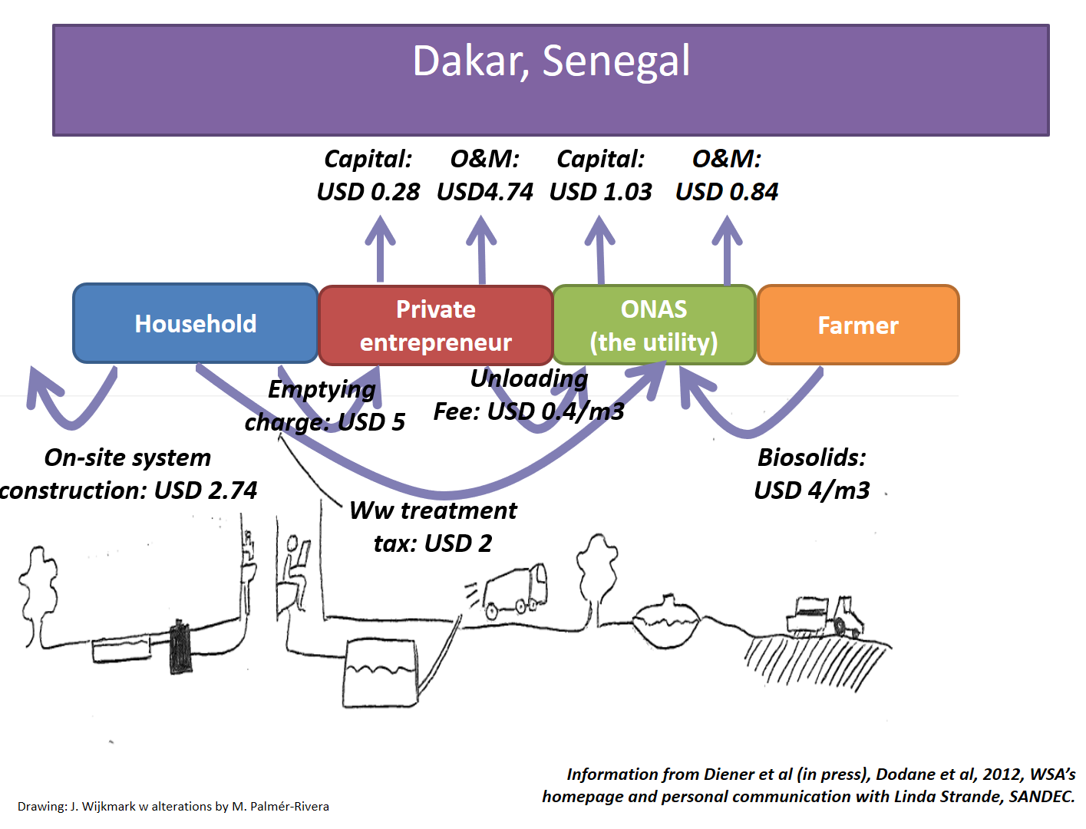
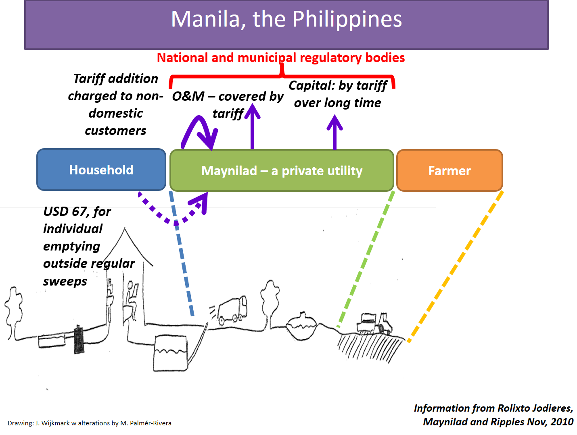

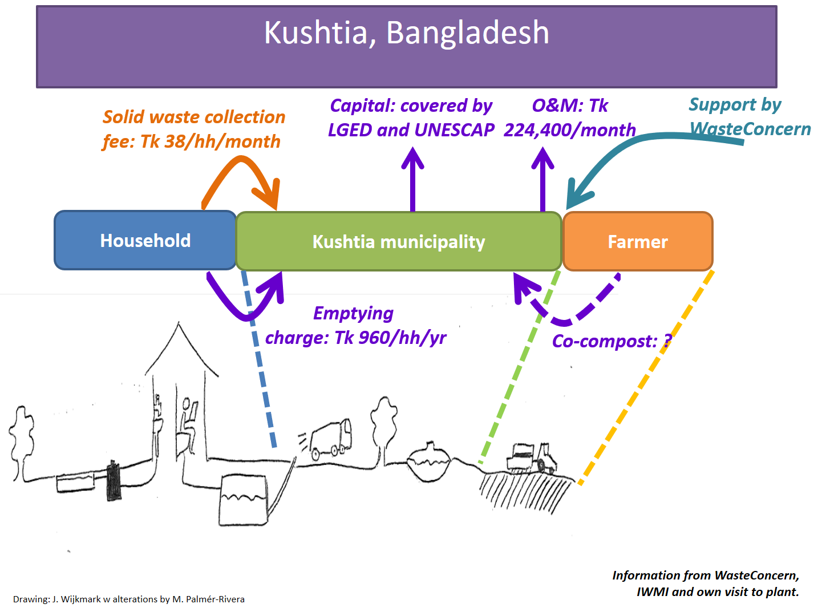

(1) The last step need not be a farmer; increasingly, there are examples of solid fuel productions as an alternative for re-use.
(2) It could be useful to consider some main service delivery functions along the sanitation chain, such as: (a) FSTP construction; (b) FSTP management; (c) vacuum tanker operators; (d) simplified emptying service providers – and the how they might be joined together or kept separate, under regulation, franchise or a tighter utility service level agreement.

Annex 3 – Detailed Technical Information to Gather on Existing FSM System

As noted elsewhere in this TOR, these lists are not meant to be exhaustive, but instead provide examples of the type of information to be gathered.

Containment | Type and operation of household (HH) and public facilities (latrines connected to pits; septic tanks; holding tanks; container-based sanitation; etc.) including whether they are sealed or covered, have lids which provide easy access during emptying and where they discharge to (to drains, to soak pits, other) or whether the effluent is stored for reuse; location and size (m³) of containment structures (pits, septic tanks and holding tanks); number of HH facilities (current and projected); whether they are individual, shared or community facilities; number of users at public facilities (current and projected); sludge accumulation rates (current and projected); emptying frequencies; accessibility of pits for emptying; quality of the design and construction for HH and public containment facilities (e.g., condition of containment, number of containment structures that are emptiable/access to containment, ability to safely contain FS); utilized capacity (m³ and users/day) of public, communal and shared facilities; estimated remaining lifespan of HH and public/communal/shared facilities; operational and maintenance requirements for HH and public/communal/shared facilities; operational and maintenance models for public/communal/shared facilities; width and quality of roads leading to HH and public/communal/shared facilities; water table level and pollution; soil types, etc.
Emptying | Frequency of emptying; main drivers behind emptying episodes (facility full, facility overflowing, rainy season coming, etc.); type of emptying equipment (e.g., vacuum trucks, hand pumps, manual emptying); size and number of trucks and handheld equipment (m³ of storage volume); type and number of providers (self-emptying, community, government, private company, NGO); functionality (of emptying and conveyance equipment); ability to safely contain/convey FS; utilized capacity of emptying equipment; estimated remaining lifespan of emptying/conveyance equipment; operational and maintenance requirements of emptying/conveyance equipment; prices charged; social status/formality of manual emptiers, etc.
Transfer | Number, size, location, and operational aspects related to the FS transfer stations (TSs) (number of operators, hours of operation, noted issues); usage (m³/day of deposited sludge); ability to safely contain FS; utilized capacity of TSs; estimated remaining lifespan; operational and maintenance requirements; traffic conditions near existing and proposed transfer and treatment sites; etc.
Treatment | Types of treatment currently available for FS; proportion of sludge being disposed of in open areas (within neighborhoods, on open land, at farms, in waterways, etc.) and/or transported to a treatment plant, for which (at current and projected design horizons): type of treatment; capacity of treatment plant (m³); location; influent FS/septage characteristics (organic load on plant, expressed as either chemical oxygen demand (COD) or the five-day biochemical oxygen demand (BOD₅) of material delivered to plant in given timeframe; the solids loading expressed as the total mass of suspended solids (TSS) delivered to plant in given time period; etc.); volume of FS/septage delivered to treatment plant in a given time period; effective influent flow rates (daily average and peak values); treated sludge accumulation rates (m³/day); effluent generated (m³/day); accessibility of treatment sites; functionality (quality of the design, construction and operation & maintenance); ability to safely treat FS to meet relevant standards or reuse; utilized capacity (current and projected, in m³/day); estimated remaining lifespan; operational and maintenance requirements; issues with regard to nuisance of treatment plants (visual, odor, noise, etc.) for adjoining communities and/or local environment); treatment efficiency achieved including quality of effluent (for sludge, for liquid effluent) and any downstream impact issues; current and proposed reuse products; availability of reliable electricity and its cost; etc.
Reuse/Disposal | Current and projected/proposed reuse products (sludge, fertilizer/compost, fuels, biogas, water, etc.); amounts produced (m³/day); numbers of buyers/users; ability to safely reuse the FS; importance of the reuse products for the buyers/users – potential market; hygiene and other perceptions of reuse products; storage volume of reuse products and storage conditions; etc.

It is assumed that this TOR will be utilized after initial tools (e.g., SFD, CWIS Costing & Planning Tool, CWIS/Strategic Sanitation Planning) have helped identify the citywide sanitation service provision needs and priorities of the city, with FSM having been identified as one of the selected approaches.
These Terms of Reference do not include for consultant support during the implementation phase of the resultant FSM interventions. If such support is also required, the TOR will need to be adapted to include appropriate details under the scope of work.
The methodology, outlined in FSM Tools: Data Collection Instruments (WB, Nov 2016), includes interviews with governments, service providers, support agencies and urban planning agencies.
See annex 1 for Political Economy Analysis Resources.
See Annex 1. Also, the Service Delivery Assessment and Prognosis for Change methodologies outlined in FSM: Diagnostics for Service Delivery in Urban Areas (WB, April 2016) may be useful for this work.
A review of the regulatory framework should include looking at: (a) norms for the institutional arrangements, design and construction of containment (i.e., of the septic tank, the pit latrine or other containment facility); (b) regulations for the operation and maintenance of the containment structure; (c) regulations for emptying practices; (d) the existence of accreditation/training processes for workers/small businesses engaged in the sanitation service chain; and (e) standards for sludge and effluent treatment and end use/reuse. Assessments should explore environmental, economic, construction, service delivery and public health regulations/bylaws/standards/norms, as appropriate. It may be important to explore land tenure issues, particularly for illegal/informal settlements, which often exist outside of the regulated sector. Information will be required not only on the regulations and related instruments themselves but also on the systems that exist for applying/ enforcing them.
For example, existing solid waste collectors in a neighborhood or city could also become fecal sludge emptiers/conveyors.
Quantity of sludge can be calculated based on sludge accumulation rates in pits/tanks or by estimating what volume of emptied sludge could be transported to a treatment site (taking account of the fact that not all sludge can easily be emptied from a given pit). It is recommended that estimates ultimately be based on amount of sludge that will reach a treatment plant. See Annex 1 for further resources.
Relevant sludge characteristics will vary based on the sources of sludge and on the types of treatment/reuse used/considered. Possible relevant characteristics include, but are not limited to: BOD₅, COD, VSS/TSS, pathogens/fecal indicators (e.g. E. coli, fecal coliforms, helminths), heavy metals, nutrients (e.g., N, P, K), sludge volume index, and sludge age. See Annex 1 for further resources.
To learn more or to generate a new SFD, visit https://sfd.susana.org/ or to generate the graphic, visit https://sfd.susana.org/data-to-graphic.
Particular attention should be paid to the topography/ground conditions including rocky ground, steep slopes, flood plains, high water tables, households living above waterways, etc., as these may constrain the recommended technical options.
For technologies to be appropriate they must address the particular issues in a given location, help work towards the broader objectives of the intervention, be in line with social norms, take account of local environmental conditions, take account of capacity to operate them, and be based on sound financing for both CAPEX and OPEX. They also need to be functional together with the other complementary elements along the sanitation service chain (e.g., the size and type of emptying equipment proposed should match the containment design in terms of volume and access).
In contexts where households are currently paying for services, ability to pay may be estimated by comparing to current payments. If households do not currently pay for service provision, other estimates may be used, as appropriate given the local context. Full willingness-to-pay studies may not be feasible given cost constraints, so other means should be considered, in agreement with the government.
Such information should be presented as costs to (a) the utility and (b) the customer – both the upfront investment costs (CAPEX) and the recurring costs (OPEX) should be presented in this way. Options considered may include cross-subsidies with related urban services (e.g., water supply, solid waste, etc.) or may include payment models that are based on leveraging existing payment models for other urban services.
An indication of customer’s knowledge about the impact of unsafe FSM and the possible disconnect between satisfactory customer front-end service provision and unsafe downstream practices should be made.
Annex 2 contains further examples.
Examples of such can be found in Annex 1 of the World Bank Container Based Sanitation report. Tremolet, Sophie, et al. 2019. Evaluating the Potential of Container-Based Sanitation: Overview Report. World Bank, Washington, DC. © World Bank. License: CC BY 3.0 IGO.
The Scope of Work for technical design and implementation does not include specific details on designing pilot/demonstration interventions. If the Consultant/Firm’s involvement in this process is required, additional details should be provided in this section of the TOR.
Including organizational structures, capacity building, office computers, equipment & software systems, and standard operational procedures (SOPs).
Example parameters to include in the M&E framework include: volume of sludge safely managed; volume of sludge not captured by the new/improved system; operating cost coverage ratio for utility/private sector operators; volume of fecal sludge safely treated/reused; income generated from sale of reuse products; number of customers served; billing collection efficiency (as appropriate); environmental impacts (nutrient/organic loads to the surrounding water bodies); customer satisfaction (including information on who is rejecting the use of FSM services and why), etc.
Taken from a presentation by Elisabeth Kvarnström (May 2014)
The range of shared sanitation solutions is more fully explained and explored in Cardone, et al. 2018 (see Annex 1).

