Tutorial session P4

The aims of this tutorial session are to:
- Manually construct a scenario for a simple example
- Manually construct an optimization for a simple example

You are asked to work in groups. The session will last for 55 minutes.

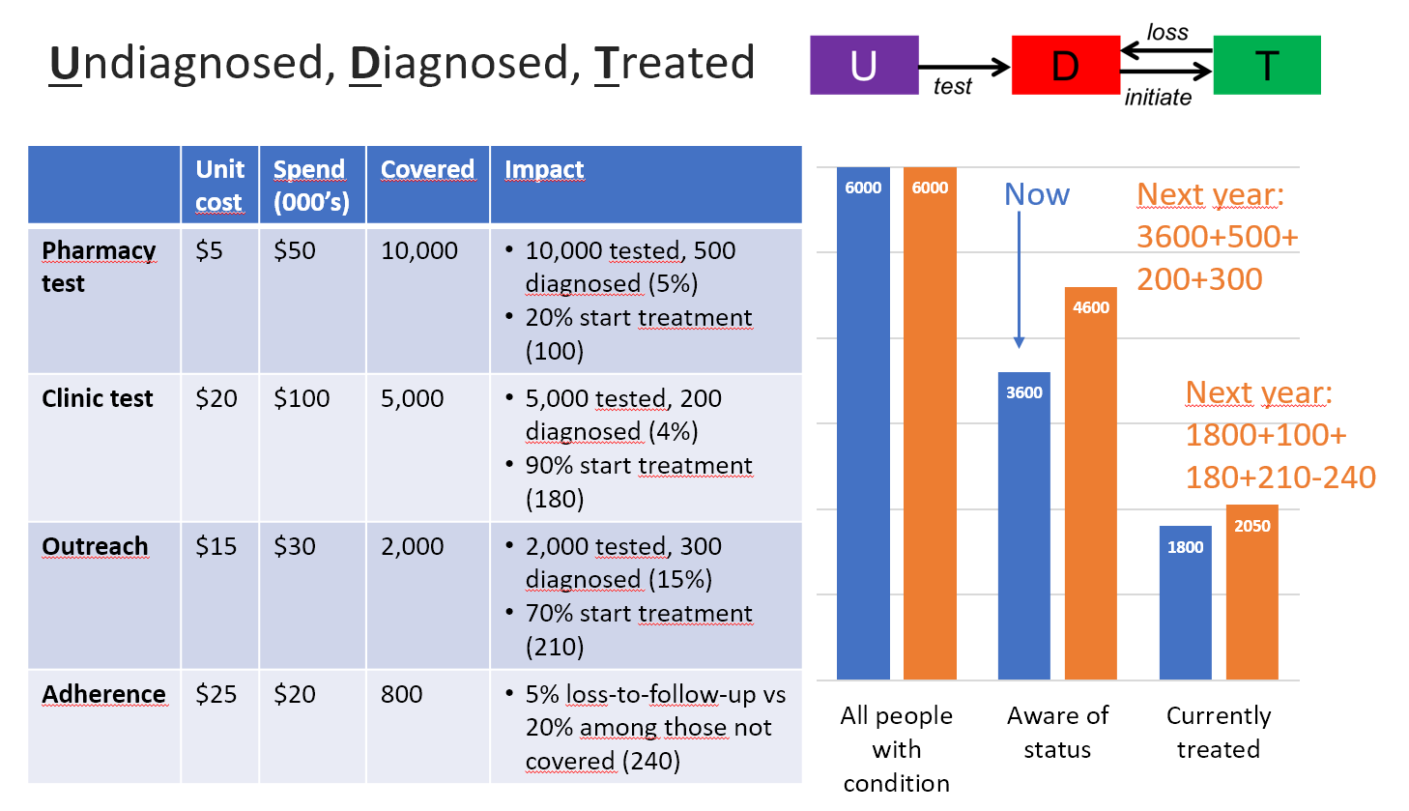

The following questions are based around the scenario example presented in session C5 (shown above)

- This example made several assumptions about the nature of the relationship between expenditure and coverage, and the relationship between coverage and outcomes. List all assumptions that you can think of.

- Suppose that instead of a linear relationship between expenditure and coverage, there was a nonlinear relationship. One relationship that health economists often consider is a saturating relationship, as pictured below:

The saturating relationship implies that there is a strict upper limit on the number of people reached by a given program, and that it becomes increasingly difficult to reach new people as program coverage scales up (and since some people are likely to be unreachable entirely no matter how much funding is allocated towards a given program). An equation that meets these requirements is:

$$c = \frac{2c_{max}}{1+e^{-2s/(c_{max}u)}}-c_{max}$$

where c is the number covered, c_{max} is the maximum number that can be reached by the program, s is the spending, and u is the unit cost at zero coverage.

How might the scenarios change if we had assumed a saturating relationship instead of a linear relationship?

The scenarios considered in session C5 are summarized in the Excel spreadsheet provided with this exercise sheet. In addition, the same scenarios are presented but constructed with nonlinear cost functions, as discussed in the previous exercise. Note that this spreadsheet is NOT the program data entry spreadsheet used by the CAT – it is simply an example of how to perform the program outcome calculations.

- What effect does decreasing the capacity constraint have on the cascade outcomes?

- How much additional funding for each program would be required in the nonlinear cost function case to achieve the same outcome as in the linear cost function case?
- We saw previously that the pharmacy test program was not the optimal program to scale up. This is because for a given amount of spending, the yield is too low for the number of tests performed, relative to the other interventions.
  - For the same yield, how much lower would the unit cost need to be for the pharmacy test program to be the best program to scale up? List some potential systematic/enabling environment interventions that could lower the unit cost for this program
  - For the same unit cost, how much higher would the yield need to be for the pharmacy test program to be the best program to scale up? List some ways you might be able to increase the yield for this program
- We only consider examples in which all of the $20,000 in additional funding was given to a single intervention. In theory, it could also be split between the interventions. Play around with the allocation of the $20,000 in order to find the best cascade outcomes you can.
Note: this is what optimization algorithms do, and you will quickly see why they do it using automated algorithms rather than manually!
- Another common type of optimization is ‘money minimization’. In that case, rather than having a fixed total budget and optimizing the allocation to achieve the best outcome, the optimization starts with a specific target outcome, and then asks what is the allocation with the minimum total budget required to achieve this.
Suppose your country had a target of having at least 2000 people in that cohort being on treatment next year. What is the minimum amount of money required to achieve this target (in the linear cost function case)?

