CAPE WORKSHOP

Session 1: Financing the transformation to a low-carbon and climate resilient economy
Moderator:

Katie Sullivan, Director North America, IETA
Katie joined the International Emissions Trading Association (IETA) in 2010, and she currently serves as the organization’s Director of both North American Policy and International Climate Finance. In this role, Katie leads IETA’s efforts to further enhance business members’ ability to engage in constructive climate policy dialogue and market design across North America, while also contributing to IETA’s growing international policy work on innovative economic instruments and public-private risk-sharing mechanisms to combat climate change. As IETA’s North American lead, Katie brings together provincial/state regulators and legislators with business leaders to modify and build workable environmental market solutions. As IETA’s climate finance lead, Katie helps develop and guide business input and output into the UN’s new financial mechanism – the Green Climate Fund (GCF). Katie also leads IETA’s Carbon Capture & Storage (CCS) Working Group activities & engagement worldwide, with a particular focus on establishing enabling finance and policy frameworks to deploy CCS at scale throughout developing regions. Prior to joining IETA, Katie worked as a senior consultant for ICF International, where she provided strategic climate advisory services and analytics to corporate, government, and international/multilateral financial clients. This work included authoring the first-ever international review & compendium of “Green Financial Products & Services” for UNEP-FI, which captured product development, experiences, and transferability of environmental financial products across banking sectors (retail, asset management, insurance, corporate & investment etc.). Katie holds a Masters in Environment, Development and Policy (with distinction) from the University of Sussex.

Speakers:

Alexandre Kossoy, Senior Financial Specialist, Climate Change Group, WBG
With over 25 years of experience, Mr. Alexandre Kossoy works in the Climate Change Group of the World Bank as a senior financial specialist. He is leading the CPLC activities in Latin America, as well as the political dialogue with public and private sector regional stakeholders for other climate-related initiatives such as the Climate Action Peer Exchange (CAPE). In addition, Alexandre has led the publication of the World Bank annual flagship report on carbon pricing – State and Trends of Carbon Pricing – since 2010. Among other activities and responsibilities, he is a member of the advisory council in the Brazilian Emissions Trading System simulation, and he has been actively involved in the design and implementation of innovative financial instruments related to climate and carbon finance. Before joining the World Bank, Mr. Kossoy was in the private sector, working in a variety of positions for international companies such as Rabobank, Pepsico, and Monsanto. Mr. Kossoy holds a Bachelor’s degree in Agricultural Engineering from the University of Sao Paulo and a Master’s degree in Environmental Engineering Sciences from the Israel Institute of Technology.

Luis Fernando Mejia, Director General, DNP
Mr. Mejía is an economist and master in economics from los Andes University, as well as a master's degree in economics from the University of Chicago, an institution where he also did doctoral studies in this discipline. Before his position as General Director at DNP, Mr. Mejía served as “Sector Deputy-Director” since 2014. Prior to joining DNP, he was Director of Macroeconomic Policy at the Ministry of Finance. In the academic field, Mr. Mejía has been Macroeconomics and International Finance professor at University of Chicago, los Andes University, and Javeriana University. Mr. Mejía was also appointed Assistant Professor of Thomas Sargent, Nobel Prize in Economics, during its doctorate at the University of Chicago. Among other honors, he received the Margaret Reid Memorial Fund of the University of Chicago, the Martin & Margaret Lee Award for Best Macroeconomics Doctorate Examination at the University of Chicago, and was selected in 2014 by “DineroMagazine” as one of the Top 50 leaders under 40 in Colombia, and is the seventh economist in Colombia by number of academic citations

Ruben Lubowski, Chief Natural Resource Economist, EDF
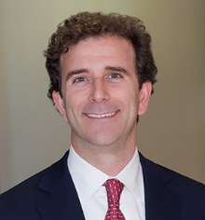
Ruben Lubowski, Ph.D., is Chief Natural Resource Economist at the Environmental Defense Fund (EDF), a non-profit environmental advocacy group and think tank, based in New York City. Ruben is an expert on carbon market design, as well as on economic and finance approaches to reduce emissions from deforestation and other land-use activities. He has analyzed carbon market designs and scenarios across a range of countries, including studies in Chile and Colombia under the World Bank’s Partnership for Market Readiness. He was a lead author of the World Bank-ICAP handbook on Emissions Trading System design and implementation and has taught environmental economics and policy as an adjunct professor at Columbia University. He received his Ph.D. and master’s degree in Political Economy and Government and his bachelor’s degree from Harvard University.

Juliana Lopes, Director Latin America, CDP
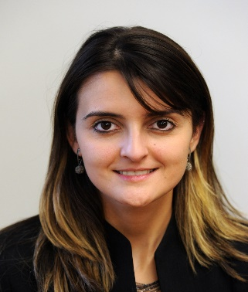
Juliana holds a bachelor´s degree in Journalism, a MBA in Marketing and a Master in Administration. As CDP's Director for Latin America, Juliana is leading the expansion of CDP project-lines over the region. Working 12 years in the Sustainability area, Juliana started her career in a NGOs focused on Water Governance, where she led civil society capacity buildings aiming a more participative and efficient water management. She was editor of a prominent Brazilian magazine called Ideia Sustentável, the first publication specialized in Corporate Social Responsibility in Brazil, where he also coordinated projects for studies and research, as well as strategic consulting on sustainability. He has worked in multinational companies such as BASF and Bridgestone-Firestone in corporate communications. Also dedicated to the development and implementation of sustainability communication campaigns for corporate clients and international organizations such as WWF.

Andrés Rojas, Vice President, Asobancaria Colombia
Economist with an emphasis on international business with a master's degree in Government and Public Policies and a specialization in International Higher Management at Universidad de los Andes. He has extensive experience in the public sector, where he served as legislative advisor and private secretary of the First Vice-Presidency of the House of Representatives, private adviser to the General Directorate and General Director in charge of the Special Administrative Unit of Civil Aeronautics. In the Organization of American States - OAS, he worked in the Summits of the Americas Secretariat, as well as in the Commercial Office of Colombia in Washington D.C. from where he supported the negotiation process of the Free Trade Agreement between Colombia and the United States. Currently holds the position of Corporate Affairs Vice President in the Colombian Banking Association – Asobancaria.

Session 2: Regional cooperation to fight climate change

Moderator:

Carolina Urrutia, Director, Semana Sostenible
Carolina Urrutia is the Director of Semana Sostenible, the area within Publicaciones Semana that focuses on generating journalistic contents at the intersection of social environmental and economic issues. As a consultant, she specialized on the linkages between poverty and the environment, focusing particularly on institutional analysis and reforms, working on those issues for the World Bank and UNDP; amongst other organizations. Carolina majored in Political Science and Public Administration in Mexico and has a Master’s in Public Policy from Harvard's Kennedy School. She has held posts at the Mexican Environment Ministry (SEMARNAT), at the World Bank in Washington DC and, in Colombia, at the Ministry of Defense, the Green Party and the National Planning Department.

Speakers:

Ian Parry, Principal Environmental Fiscal Economist, IMF
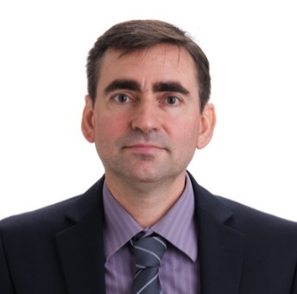
Ian Parry is the Principal Environmental Fiscal Policy Expert in the Fiscal Affairs Department of the IMF. Prior to joining the IMF in 2010, Parry held the Allen V. Kneese Chair in Environmental Economics at Resources for the Future. He has a PhD in economics from the University of Chicago.
Parry’s research focuses on analytical and spreadsheet models to quantify for different countries the economic impacts and efficient levels of a wide range of environmental, energy, and transportation policies. His work emphasizes the critical role of fiscal instruments to address externalities and raise revenue. His recent (co-authored or co-edited) books include Energy Tax and Regulatory Policy in Europe: Reform Priorities; Implementing a US Carbon Tax: Challenges and Debates; Getting Energy Prices Right: From Principle to Practice; Fiscal Policy to Mitigate Climate Change: A Guide for Policymakers; and Issues of the Day: 100 Commentaries on Environmental, Energy, Transportation, and Public Health Policy.

Thomas Kansy, Head US, Vivid Economics
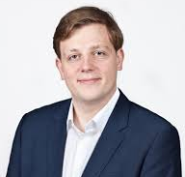
Thomas Kansy is an Engagement Manager at Vivid Economics and is leading the carbon pricing practice. He has over five years’ experience in energy, carbon pricing and climate change policy. Thomas contributed to the State and Trends of Carbon Pricing 2016 report, leading the work on the benefits of international an international carbon market and how carbon pricing aligns with the broader policy landscape and worked on creating guidelines for international linking post-Paris, competitiveness impacts of carbon pricing, tax reform when implementing carbon taxes and the future of fiscal policy in energy. Thomas works with energy companies, governments and international organizations. He holds a Masters in Economic and Financial Research with specialization in econometrics and a BSc in International Economic Studies from Maastricht University.

Isabel Cavelier, Senior Adviser, Mission 2020
Isabel Cavelier is co-founder and Director of Vision of Transforma and senior adviser for Mission2020. She has worked for several years on sustainable development and climate change, as part of the Colombian Ministry of Foreign Affairs where she most recently served as Minister Counselor for the Permanent Mission of her country to the UN in New York. She has extensive experience in multilateral negotiations, and was one of the founders of AILAC, a group of 8 countries driving ambition in the multilateral climate change negotiations leading to the Paris Agreement; she served as the first leader of the group's support unit. She has also worked in the field of human rights and gender equality, and as part of her academic life she has various publications on international environmental law, Colombia's foreign policy, climate finance, climate change and human rights, gender justice, internal displacement and the armed conflict in Colombia, among other. She holds an LLM in public international law from Cambridge University, and is a lawyer and professional in languages from Los Andes University.

Adrien Vogt-Schilb, Climate Economist, IADB
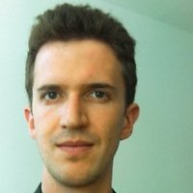
Adrien is a climate change economist at the Inter-American Development Bank. Adrien's work focuses on the design of effective and politically-acceptable emission-reduction policies: how to align NDC implementation with local development goals and the long-term decarbonization imperative, while navigating the political economy. He also works on quantifying the effect of policies that build socio-economic resilience to natural disasters and climate change, and on methods to make sure investment in infrastructure is consistent with uncertain climate change. Before joining the IADB, Adrien worked three years with the World Bank, where he published 3 books and many academic papers on climate policy. Adrien is a trained engineer and holds a PhD in climate economics.

Grzegorz Peszko, Lead Economist, WBG
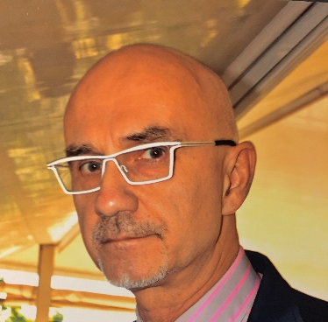
Grzegorz Peszko is a Lead Economist in the Climate Change Group of the World Bank, where he leads analytical and advisory services on economics of energy and climate change. He has over 25 years of experience in energy and environmental economics, finance and carbon pricing. He has lead project and analytical work in Europe and Central Asia, Africa, South Asia, East Asia, Latin America and Caribbean, and Middle East and North Africa. Prior to the World Bank he spent 6 years as a Lead Energy Economist in the European Bank for Reconstruction and Development (EBRD), where he was appraising energy projects and leading policy and regulatory dialogue on integration of energy and climate policies. Before working for development banks, Grzegorz spent 5 years as an economist at the OECD Environment Directorate leading environmental finance program. Prior to that – for 12 years – he was assistant professor of environmental economics at the Krakow University of Economics and a Board member of the Malopolska Environmental Fund, working at the same time as a project, policy and finance expert and consultant for various private and public clients, as well as a radio and TV journalist. He was the Lead Author of the IPCC Third Assessment Report. He has PhD from the Krakow University of Economics, MSc in Resource Economics from the University College London and MSc from the Krakow Yagiellonian University.

Session 3: Fiscal reforms for climate action
Moderator:

Pablo Correa, editor of Ambiente y Ciencia, El Espectador
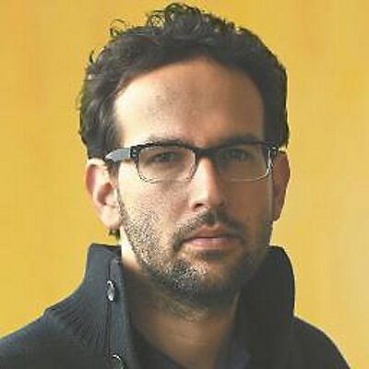
Journalist specialized in health, environment and science with eleven years of experience in the media. Journalist and editor of the section living in the newspaper El Espectador. Free-lance for the magazine QUO in Mexico, portal O-eco Amazonia and correspondent of SciDev.Net, network dedicated to dissemination of science in developing countries. Former Fellow of the Scientific Journalism Program of the Massachusetts Institute of Technology 2012-2013. Professor at Universidad Javeriana, Universidad Santo Tomás and Universidad de los Andes on issues related to scientific journalism. Editor of books published by the editorial arm of El Espectador. Recently, a consultant for the Amazonas 2030 initiative, a civil society initiative dedicated to following up policies related to the Amazon region.
Speakers:
Andrés Velasco, Acting Vice Minister, Ministry of Finance, Colombia
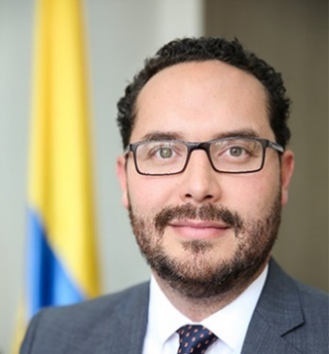
He is an Economist and Master in Economics of the Javeriana University, and MPhil in Economics of the University of Oxford, where he also studied Doctorate in Economics. He has worked as an expert economist at the Research and Economist Unit specialized in Inflation at the Banco de la República and as a Junior Researcher at Fedesarrollo. He has been a professor of macroeconomics at the universities of Oxford, Andes, Rosario, Javeriana and Sabana.

Rodrigo Pizarro Gariazzo, Head Environmental Information and Economy, Ministry of Environment, Chile
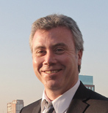
Economist at the London School of Economics, MSc at the University of North Carolina, PhD. Stanford University. Academic of the University Of Santiago De Chile, visiting professor of the University of Stanford. He served as Executive Director of the Terram Foundation. He has served as an advisor to the Minister of Economy, Minister of Public Works and Transportation and official of the Central Bank.

Luis Rosa Perez, General Director of Environmental Economy and Finance, Ministry of Environment, Peru
Economist with 14 years of experience in the design and management of sustainable development programs and projects, support to competitiveness and innovation. Focused on achieving tangible results in favor of inclusive productive sectors, through the management of multidisciplinary teams, applying a social, environmental and economic sustainability approach. As General Director of Evaluation, Evaluation and Financing of the Forest Heritage, he leads a professional team in charge of developing economic and financial instruments that contribute to the conservation and sustainable use of natural resources.

Jasmin Chakeri, Program Leader, WBG
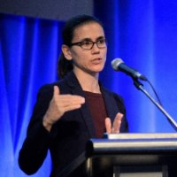
Jasmin Chakeri is the World Bank’s Program Leader for Equitable Growth, Finance and Institution for Mexico and Colombia, based in Bogota. In this capacity she leads the World Bank’s program on macroeconomics and fiscal management, trade and competitiveness, financial sector and governance in these two countries. With the World Bank since 2001, she has extensive experience working on macroeconomic and fiscal policy in Latin America, East Asia and West Africa. Jasmin holds a BA from the University of Cambridge and an MA from Johns Hopkins University – SAIS.

Session 4: Financing forest conservation, fighting deforestation

Moderator:

Paola Agostini, Lead Environment Specialist, WBG
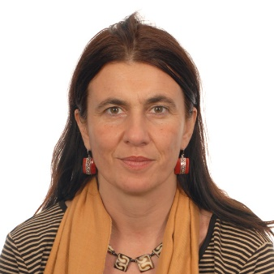
Paola Agostini is the Global Lead for Forests, Landscapes and Ecosystem at the World Bank Environment and Natural Resources GP. In the last 20 years and in different positions at the World Bank she has been working on projects at the interface of Environment and Agriculture in both Africa and Latin America with a particular focus on Sustainable Land Management, Protected Areas, Forests, Payment of Ecosystem Services and Territorial Development. She was also based in FAO Rome for more than 8 years, where she was the World Bank focal point for the Rome UN based organizations. In addition she has been leading TerrAfrica Partnership on Sustainable Land Management. She holds a PhD in Economics from University of California-San Diego and a Master of Art in Economics and Social Sciences from Universita Bocconi, Milano.

Speakers:

Isabel Studer, Regional Executive Director, The Nature Conservancy
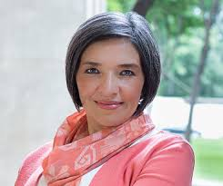
She was Founding Director of the Global Institute for Sustainability and Leader of Energy and Corporate Sustainability at EGADE Business School at Tecnológico de Monterrey, as well as director of the Greening of Productive Chains program (MIF and Tec de Monterrey program). She was a fellow of Fulbright and Ford.Dr. Studer has held several positions in the Mexican government. General Director of Cooperation and Bilateral Economic Relations at the Mexican Agency for International Cooperation for Development (AMEXCID, for its acronym in Spanish), Deputy General Director of Canada at the Ministry of Foreign Affairs and General Director for the United States and Canada at the Ministry of Environment and Natural Resources (SEMARNAT, for its acronym in Spanish), where she served as the Secretary's alternate representative to the North American Commission on Environmental Cooperation (CEC). She was also Director of Research for the Commission for Labor Cooperation (CCL for its acronym in Spanish) in Washington, DC. In 2013, Dr. Studer received academic-scientific recognition from the Petroleum and Energy Magazine and in 2012, 2013, 2014 and 2015 was recognized as one of the 100 most important leaders in the Mexican energy sector. Isabel Studer is a PhD and professor in international relations at the School of Advanced International Studies at Johns Hopkins University and a degree in international relations from El Colegio de México. She has written extensively on climate change, trade and environment, renewable energy and economic integration, regional governance, automotive industry, and labor markets and migration.
Brigitte Baptiste, General Director, Humboldt Institute
Baptiste is a biologist of Universidad Javeriana, where she graduated with a thesis on the ecology of fishing in Araracuara, Amazonas. Between 1992 and 1994 he completed a master's degree in conservation and tropical development in Gainesville, University of Florida, thanks to a grant from the Fulbright Commission. His undergraduate work focused on the management of forests by rural communities in Boyacá Andes, Colombia. In 2001 and 2002, as a Rusell Train Fellow (WWF), she advanced additional postgraduate studies in Environmental Sciences (Ecological Economics and Natural Resource Management) at the Autonomous University of Barcelona. He developed additional studies in the U of San Carlos de Guatemala and CATIE (1989) and in the U of Mérida (Venezuela) in topics of protected task management and tropical ecology, and biodiversity monitoring at the Smithsonian Institute in the Shenandoha National Park (USES). He received a PhD Honoris Causa in Environmental Management from Unipaz in 2016.

Elsa Matilde Escobar, CEO, Fundación Natura
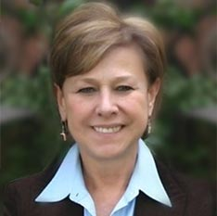
He is Pure Chemistry and MSc in Mathematics, and holds Diplomas in Administration, Finance and Project Management, in Management of Civil Society Organizations and in Gender and Development. She has been the Executive Director of the Natura Colombia Foundation since 1997. Under her initiative, the Natura Regional Foundation, the Natura Certification Foundation, the Voluntary Mechanism for Mitigation of GEI-MVC Colombia and the Carbon Bank have been set up. Elsa is also currently President of the Natura Certification Foundation, President of the Biocomercio Corporation, vice president of the International Sustainable Agriculture Network, and member of the boards of the following organizations: GRI Hispanic-American Council (Habitat Foundation) , Natural Heritage Fund, National Environmental Forum, GEF Small Grants Governing Council, Critical Ecosystem Partnership Fund, GEF-OSC National Focal Point. He is a founding member of the Colombian Committee and the Regional Committee of the World Conservation Union (IUCN).

Carlos Alberto Botero, Vice Minister, Ministry of Environment and Sustainability Development Colombia
Doctor and surgeon, Specialist in Health Services Management. Carlos Botero was Governor of Risaralda, Manager of the San Jorge University Hospital, Santa Mónica Hospital and Clínica Sur Occidente.

