Optima Nutrition exercises

Module 1: Creating an account

In order to use Optima Nutrition you will need to create an account and sign in.

- Follow this link to the login page: nutrition.ocds.co
- Click on Register here (Figure 1)

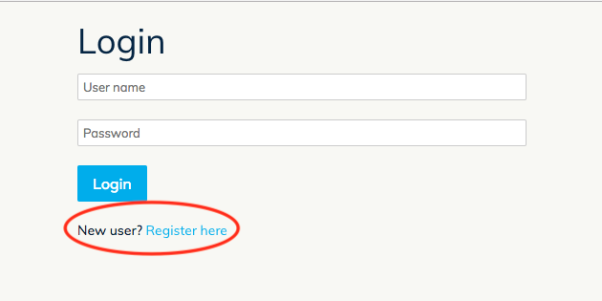
Figure 1. The login page.

- Enter a user name, a password. Optionally, you may also enter a display name and an email. Click Register.
- Enter your user name and password to login.
- You will be directed to the Projects page (Figure 2). Click Add demo project and a project will be loaded and opened in your session. This project contains data we have pre-filled for you.

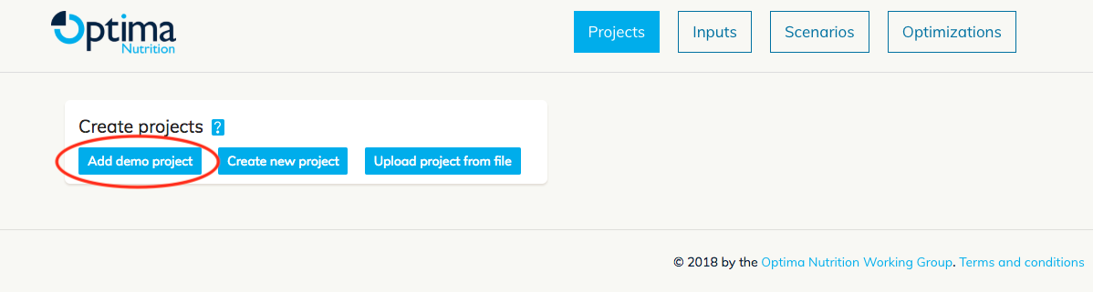
Figure 2. The projects page.

- You are able to rename the project, copy or delete it. Please download the pre-filled data book and familiarise yourself with it, since this will be the main dataset used during the workshops (Figure 3).

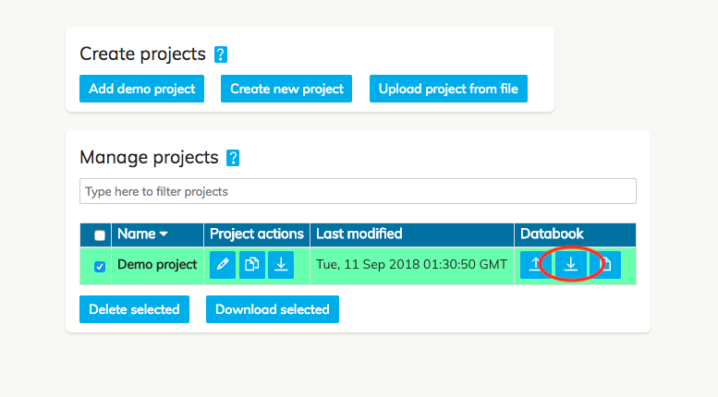
Figure 3. Demo project data.

Module 2: Modelling stunting in Optima Nutrition

These exercises are designed to guide you through the stunting components of Optima Nutrition. Specifically, we will be looking at the impact of interventions on stunting.

- Baseline scenario. Navigate to the Scenarios page (Figure 4). Here you will find several pre-loaded example scenarios. In Optima Nutrition, a baseline scenario refers to a scenario in which intervention coverages/budgets remain at initial values throughout the simulation period.
  - Run the baseline scenario only by de-activating any other scenarios (Figure 4).
    - What are the estimated total number of child deaths and stunted children between 2018 and 2030?
    - What is the estimated stunting prevalence in 2030 without changes to interventions?
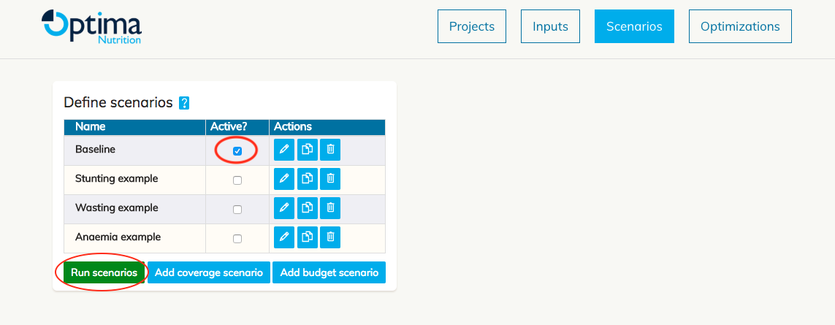
Figure 4. Scenarios page.

- Scaling up/down stunting interventions. For these exercises, we will be scaling-up the coverage of interventions in the first year (2018) until the end of the simulation period (2030). Click on Add coverage scenario to define and run the following scenarios.
  - Scale-up public provision of complementary foods (PPCF) from baseline coverage to reach 95% coverage in 2018 (Figure 5). What is the impact on the number of stunted children?
  - Scale-up Lipid-based nutrition supplements (LNS) to reach 95% coverage in 2018. What is the impact on the number of stunted children? What does LNS do that is different from PPCF?
  - Repeat for Zinc supplementation. What is the impact on the number of stunted children and how is this different from PPCF?
  - Scale-up both PPCF and Zinc supplementation simultaneously. What do you notice about the impact on outcomes when scaling-up the interventions together? Is the impact additive or otherwise?

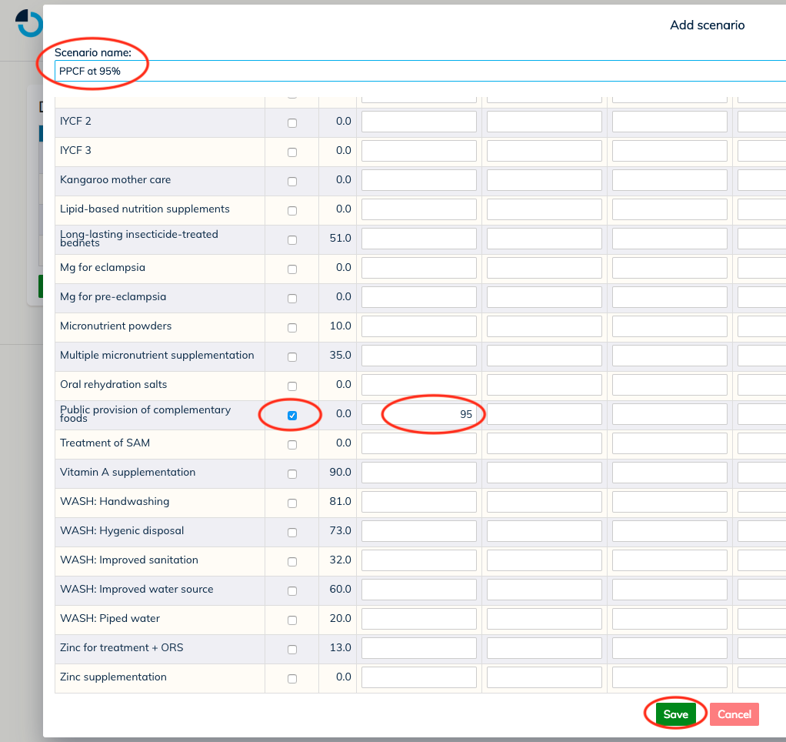
Figure 5. Defining PPCF at 95%.

- Infant and young child feeding (IYCF). Optima Nutrition also allows you to define your own (IYCF) intervention, giving you control over delivery modalities and target populations (Figure 6).
  - Define an IYCF intervention that targets all children under 59 months who visit a health facility. Scale-up this package to 95% coverage in 2018.
    - What is the impact on the number of alive and non-stunted children leaving the model?
    - What is the impact on stunting prevalence?
  - Define an IYCF package that is targeted at all pregnant women, and scale-up its coverage up to reach 95% coverage in 2018.
    - Was the impact greater for (3a) or (3b)?
    - Can you explain this?
  - Can you define an IYCF package that will yield the greatest impact?

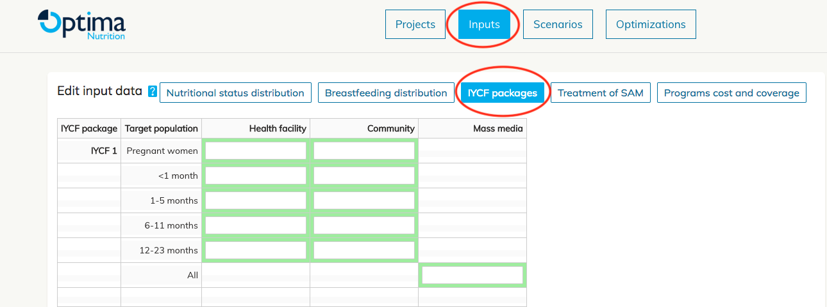
Figure 6. Defining IYCF packages.

- Relative impact. The impact of altering an intervention’s coverage is dependent upon its baseline coverage. The baseline coverage for each intervention has been preloaded in the input data book, but you are able to edit this within the web app (Figure 7).
  - The baseline coverage of PPCF was originally set to 0%. Change the baseline coverage to 50%, then repeat exercise 2a.
    - Is the impact of this scale-up larger here or in 2.a?
    - Can you explain this?

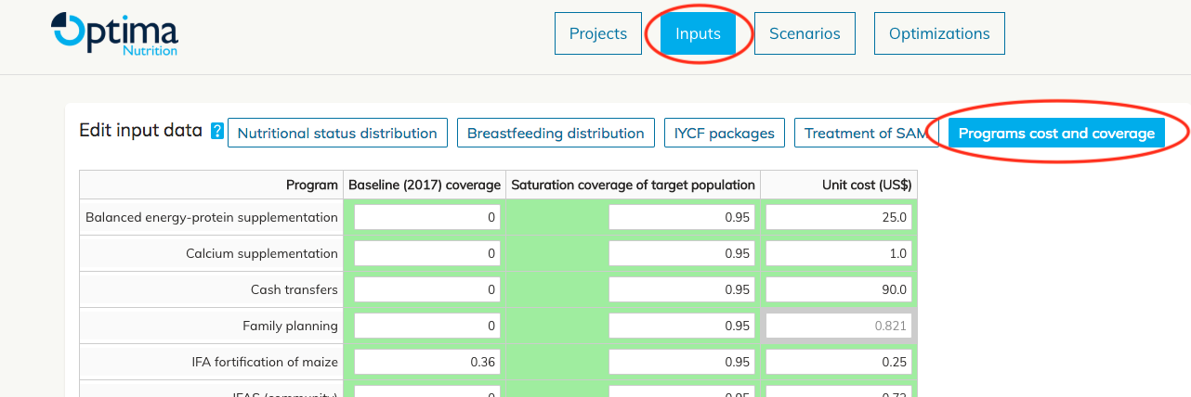
Figure 7. Changing baseline coverage.

Module 3: Modelling wasting in Optima Nutrition

In this session we will look at the interventions which impact wasting in Optima Nutrition. Broadly speaking, interventions can either prevent or treat wasting.

- Define a baseline scenario as covered in the previous exercises.
- Preventing wasting.
  - Scale up cash transfers and PPCF alone, and in combination, to reach 95% coverage in 2018. Can you explain the impact on stunting and wasting prevalence?
- Treating wasting.
  - Scale up treatment of SAM to reach 95% coverage in 2018. What do you notice about the overall wasting prevalence compared with baseline?
  - Modify the treatment of SAM intervention to include management of MAM (Figure 8) and repeat exercise 3a. What is different?
  - How can you maximize the impact of treatment of SAM?

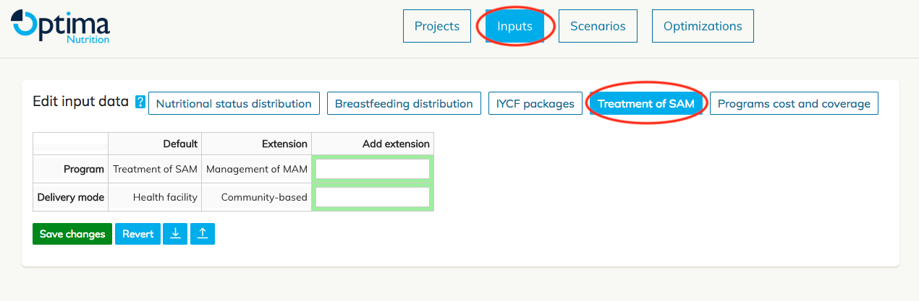
Figure 8. Extending treatment of SAM.

- Budget scenarios. Budget scenarios are defined similarly to coverage scenarios, except that instead of defining the coverage of interventions as percentages, the coverage of interventions are specified as US$. To do this you must select ‘Add budget scenario’ instead of ‘Add coverage scenario’. Ensure management of MAM is turned off and delivery is only within health facilities for these exercises.
  - Define a budget scenario with Treatment of SAM at $18 million per annum from 2018-2030 (Figure 9). What is the estimated impact of $18 million per annum on mortality?
  - Define a budget scenario with Treatment of SAM at $20 million per annum from 2018-2030. What is the estimated impact of $20 million per annum on mortality?
  - Compare (a) and (b). What is the cost per death averted from the first $18 million, and what is the cost per death averted from the final $2 million?

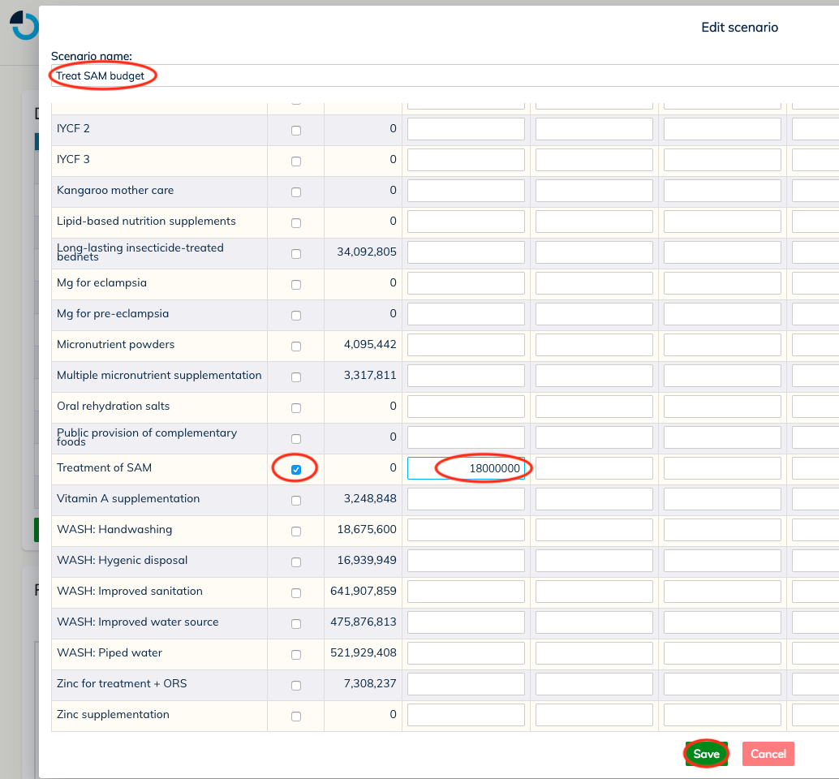
Figure 9. Defining a budget scenario.

Module 4: Modelling anaemia in Optima Nutrition

Optima Nutrition contains a large number of interventions which impact anaemia prevalence in children as well as pregnant and non-pregnant women of reproductive age.

- Anaemia interventions. In this exercise we will explore the impact of anaemia interventions on different population groups and model outcomes.
  - Define a coverage scenario and scale-up the spending of micronutrient powders to reach 95% in 2020.
    - Which outcomes are impacted, and for which population groups? Is this to be expected?
    - Why is there no impact on the number of child deaths?
  - Iron and folic supplementation (IFAS) may be given to pregnant women to treat iron-deficiency anaemia, either through a health facility or within the community. Scale-up IFAS for pregnant women (community) spending to US$4 million 2018.
    - What is the impact on anaemia in pregnant women?
    - What is the impact on stunting in children?
  - Scale-up IFAS for pregnant women (health facility) to US$4 million in the first year.
    - What is the impact on anaemia in pregnant women?
    - What is the impact on stunting in children?
  - What is the difference between (b) and (c)? What do you think is the cause of this difference?
- Intervention dependencies. This exercise will investigate the functionality of intervention dependencies in Optima Nutrition. This is an important component of the anaemia model, because in some real-life contexts it is either inappropriate to provide two supplement interventions to the same person (called an exclusion dependency), or to provide one intervention without another (called a threshold dependency).
  - Define a scenario with IFAS for pregnant women (community) scaled up 95% coverage in 2018.
  - Define a scenario with multiple micronutrient supplementation (MMS) for pregnant women scaled up to 95% in 2018.
  - IFAS for pregnant women cannot be provided alongside MMS because both contain iron. Define a scenario with both of these interventions scaled up to 95% in 2018. Run all three scenarios together for comparison.
    - What is the impact of scenarios a-c on anaemia prevalence among pregnant women?
    - Are the results of (c) consistent with those of (a) and (b)? Why or why not?
  - In some situations, MMS is not provided to pregnant women without intermittent preventive treatment in pregnancy (IPTp) for malaria. Define a scenario with IPTp and MMS both scaled up to 95% in 2018. What is the impact on anaemia prevalence among pregnant women?
  - Define a scenario with IPTp at 0% and MMS scaled up to 95% in 2018. What is the impact on anaemia prevalence among pregnant women?
  - Run (d) and (e) together for comparison.
  - How do the results of (d) and (e) compare with (b)? Can you explain this behaviour?

Module 5: Other nutrition-sensitive and supplement interventions

Family planning is different to many of the other interventions in Optima Nutrition, since it impacts the total number of children being born into the model rather than altering nutritional distributions or mortality rates.

- Family planning. Define and run a coverage scenario with family planning scaled up to 95% in 2018. What is the impact on the number of child deaths?
- Diarrhoea as a risk factor. Diarrhoea is a risk factor for stunting and wasting. There are several interventions in Optima Nutrition that can reduce the incidence of diarrhoea, including Vitamin A supplementation (VAS) and zinc supplementation (ZS).
  - Define a scenario with VAS scaled up to 95% by 2020.
  - Define a scenario with ZS scaled up to 95% by 2020.
    - What is the impact of (a) and (b) on stunting and wasting prevalence?
    - Which prevalences show the largest reduction, and why do you think this is the case?
- Changing default parameters. While Optima Nutrition has a set of default parameters pre-loaded, it is possible to adjust these values. Altering these values can produce very different results, so this should only be done when the evidence to support it is strong.
  - By default, the affected fraction of VAS is 34% of children 6-59 months with diarrhoea. Change this to 0% for all age bands. What impact do you think this will have on the overall effectiveness of VAS?
  - By default, the affected fraction of ZS is 30% of children under 59 months with diarrhoea. Change this to 0% for all age bands. What impact do you think this will have on the overall effectiveness of ZS?
  - Using these new values for VAS and ZS, define and run scenarios as in 2 (a) and (b). Compare the results of these scenarios with 2 (a) and (b). Are these consistent with your answers in 3 (a) and (b)?

Module 6: The data input book: common data sources and model inputs

Before an analysis can be performed, the input data book needs to be completed. Green cells indicate essential data to be provided by the user. In this session you will select a country to use for your analysis (some have been provided or you can select your own). Below you will find some definitions and hints for certain parameters.

- Baseline year population inputs:
  - Projection years: Enter the baseline year (2017) and the final year for the simulation (2030).
  - Population data. Below you will find some expanded definitions alongside some hints for locating this data based on Tanzania.
    - Fraction food insecure: the proportion of the population is below the poverty line
    - Risk of malaria: the fraction of the country where malaria is prevalent.
    - School attendance
      - Tanzania: DHS report page 61, table 3.2.1 (p. 61), ‘Secondary+’ column.
    - Pregnant women attending health facility.
      - Tanzania page 178, table 9.2, the fraction of pregnant women who have four or more antenatal care visits.
    - Children attending health facility.
      - Tanzania: assume that children attend with mothers. DHS page 188, table 9.8, mothers who south postnatal care in previous two years.
    - Family planning need: fraction of women who have a demand for family planning that is currently unmet.
      - Tanzania: DHS page 136, total unmet need for limiting and spacing.
  - Age distribution of pregnant women: The fraction of the pregnant women population in each age band (sum to 100%)
  - Birth spacing: the fraction of births in each birth spacing categories.
  - Mortality:
    - Child mortality:
      - Tanzania: DHS page 163, table 8.1
- Demographic projections: Projected figures for key population groups.
- Causes of death: The fraction of deaths by cause.
- Nutritional status distribution
  - Stunting and wasting:
    - Tanzania: DHS page 237, table 11.1
  - Anaemia:
    - Children
      - Tanzania: DHS page 246, table 11.7
    - Women
      - Tanzania: DHS page 250, table 11.9
- Breastfeeding distribution:
  - Tanzania: DHS page 239, table 11.2
- Time trends: This can remain blank for this session.
- IYCF packages: Define up to three IYCF packages you would like to use in the analysis.
- Treatment of SAM: Decide whether to manage MAM and extend to community level.
- Programs cost and coverage: Provide baseline coverages and unit costs for interventions you want to use in your analysis.
- IYCF cost: Provide a component-wise cost for each IYCF package. Costs are summed across selected components.
- Program dependencies: Defining dependencies in this tab is optional.

Module 7: Costs and cost-coverage relationship

For many nutrition interventions, estimating the unit costs can be difficult. Often unit costs need to be estimated from a range of sources, which can require some creative thinking.

- Estimating unit costs. Kangaroo mother care (KMC) is an educational intervention promoting skin-to-skin contact between mothers and newborn children. Greater coverage of KMC reduces the likelihood of death in preterm babies. Use the following data (collected for Tanzania) to calculate the unit cost of KMC. In this case the unit cost would be defined as the cost per preterm birth.
  - Midwives earn on average US$3,368 per annum.
  - In 2012, Tanzania had 0.428 nurses and midwives per 1000 people.
  - In 2017, Tanzania’s population was 55.57 million people, with 2.11 million births.
  - 14% of national births are preterm
  - It costs US$390 to train a midwife over 5 years.
- Shape of cost-coverage curves. Figure 10 illustrates four possible types of cost-coverage curves for interventions, classified by the behaviour of their marginal costs (constant, increasing, decreasing and mixed). In Optima Nutrition, cost-coverage curves are specified for each intervention and determine the relationship between spending and the number of people covered.
  - Discuss the advantages/disadvantages of using each of the following in an analysis:
    - Constant
    - Increasing
    - Decreasing
    - Mixed
  - Data for cost-coverage relationships is rarely available. In the absence of good data to inform your curve, which curve type do you believe is most sensible to use as a default assumption?

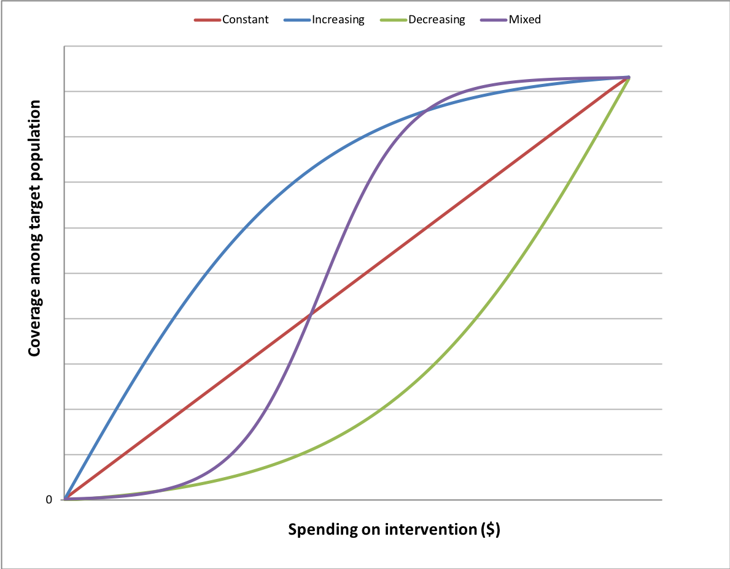
Figure 10. Cost coverage curve examples.

Module 8: Optimisation and the objective function I

The choice of objective function is crucial when using Optima Nutrition. Moreover, when selecting an objective, it is important to consider what model outcomes are not being prioritized, since this can lead to potentially counter-intuitive results.

- For a set of interventions that you would like to consider, provide a qualitative description for each model outcome and key interventions when optimising for the objectives:
  - Stunting prevalence
  - Wasting prevalence
  - Anaemia prevalence in children
  - Anaemia prevalence in women
  - Child deaths
  - Pregnant women deaths
  - Thrive (number of alive, non-stunted children)
- One possible solution for making policy recommendations is to define a combined objective function. For example, you could define an objective function which aims to maximise the number of healthy children: that is, to maximise the number of alive children that are not stunted, wasted or anaemic.
  - Based on the previous exercise, which interventions do you think that this would favour? Hint: consider the relative burdens and costs of interventions that impact the individual conditions.
  - What are the ethical issues associated with this objective?
- Without using the GUI, consider two hypothetical optimizations, both aiming to minimize the number of stunted children. For this exercise assume all baseline coverages are at 0%.
  - The first contains the only interventions vitamin A supplementation and oral rehydration salts (but not the interventions IYCF and public provision of complementary foods)
  - The second contains an IYCF package targeted at everyone and public provision of complementary foods (but not vitamin A supplementation or oral rehydration salts)
  - Based on the previous scenarios that you have run, do you think (a) or (b) will produce a better objective value (i.e. which optimization will result in fewer stunted children)?
  - For which objectives would (a) be preferable to (b)?
- Reflect upon what you have learned regarding the importance of the objective function for optimisation:
  - Should objective functions be defined to answer specific or general optimisation questions?
  - What other factors should you consider when when specifying an objective function?

Module 9: Optimisation and the objective function II

In this session you will be able to check the answers you provided in the previous workshop by running these optimisations in the GUI.

- Set up some optimisation scenarios with the interventions (Figure 11): IYCF (targeted at all children at the community level), Lipid-based nutrition supplements, Multiple micronutrient supplementation, Micronutrient powders, Public provision of complementary foods, Treatment of SAM (management of MAM turned on, community level), Vitamin A supplementation and Zinc supplementation. Don’t fix current expenditure and specify $0 additional funds (Figure 12).
  - Define and run an optimization for each objective listed in Module 8.1.
    - Are the results consistent with your responses in 8.1? If not, why not?
    - Take note of any allocations that were unexpected. What could be the reason for this?
  - Define and run an optimization with the following objective function: maximize the total number of non-stunted, non-wasted and non-anaemic children who age out of the model.
    - Are the results consistent with your response in 8.2? If not, why not?
- It may be desirable that current expenditure is maintained and only additional funds are optimised across interventions.
  - Add an additional $10 million of funding and repeat the optimisations in (1), with existing funding fixed. Which interventions is additional money best invested in?

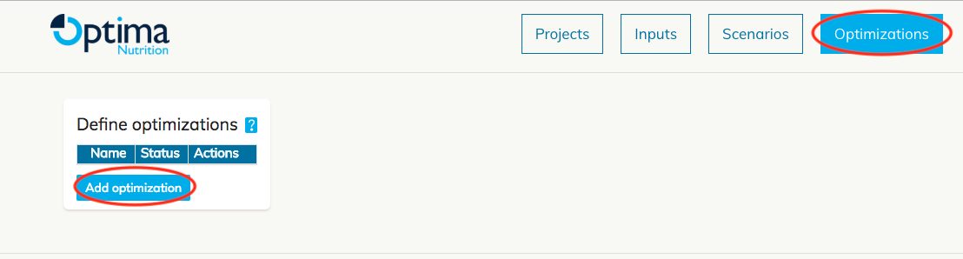
Figure 11. Creating an optimisation.

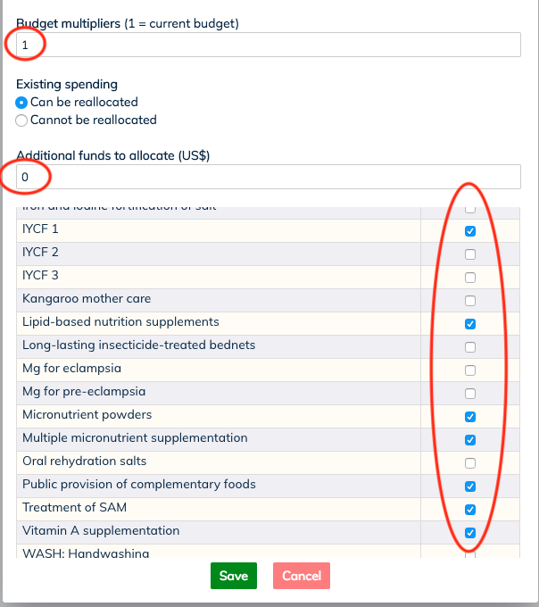
Figure 12. Specifying optimisation settings.

Module 10: Geospatial optimisation

In this session we will look at geospatial optimisation. Previously we ran optimizations within a single country and the model provided us with the optimised allocation across interventions for a given objective. With geospatial optimisation we are able to answer the question: for a given set of regions and interventions, what is the optimal allocation between the regions?
- Consider the following questions:
  - In which real-world applications do you think a user would benefit from using geospatial optimisation instead of regular optimisation?
  - In terms of demographic and intervention data, devise a hypothetical two-region analysis in which:
    - Funds are split relatively evenly between two regions.
    - Most of the funding is given to one region.
- Define a three-region geospatial optimization using the interventions in Module 9.1. For this exercise do not fix current expenditure and set additional funds to $0.
  - Run optimizations for the objectives in Module 8.1.
    - Are the regional allocations similar across each objective or do they vary significantly?
    - Are the intervention allocations similar to those in Module 9.1? Can you explain any observed differences?

Module 11: Completing your analysis

This session is intended to be more self-directed than previous sessions. Using the skills you have acquired in the previous modules, perform a series of scenario and optimisation analyses. It is good practice to have specific questions and goals in mind when doing so. Make a note of any unexpected results and attempt to understand them.

