STANDARD PROCUREMENT DOCUMENTS
STANDARD FORM OF AGREEMENT for Use by World Bank Borrowers
Procurement of Supplies by UNFPA under Bank-Financed Projects
FRAMEWORK AGREEMENT

The World Bank

v.3
January, 2020

This document is subject to copyright.

This document may be used and reproduced for non-commercial purposes only. Any commercial use, including without limitation reselling, charging to access, redistribution, or for derivative works such as unofficial translations based on these documents, is not allowed.

Foreword

This Standard Form of Agreement is a result of cooperation between the World Bank (“Bank”) and the United Nations Population Fund (“UNFPA”).

The World Bank’s Borrowers shall use this Standard Form of Agreement when the requirements of the applicable Bank rules for procurement from UN Agencies are satisfied.

This Standard Form of Agreement represents a framework arrangement put in place for the duration of a programme (or a project). Individual purchase requests are placed by the Borrower depending on re-stocking planning within the period covered by the Agreement and up to the maximum price ceiling set up in the Agreement (“Total Funding Ceiling”). The completion date of the Agreement and the delivery of the last order cannot exceed the Project’s closing date.

The text shown in Italics is “Notes to Users”. These Notes provide guidance to the implementing entity in preparing a specific Agreement. These Notes should be deleted from the final version prior to signing of the Agreement.

Those wishing to submit comments or questions on this document, or guidance on the use of this template, shall contact unagencies@worldbank.org.

Questions by UNFPA staff concerning this document should be addressed to procurement.services@unfpa.org.

Revisions to the Standard Agreement template

1. December 2019 revision (version 3) reflects updated references to UNFPA’s version of the financial rules and regulations and the World Bank’s Procurement Regulations for Investment Project Finance Borrowers; upgrades of UNFPA website with the electronic catalogue and forms used in this Agreement; introduction of instructions for processing electronic payments; and some editorial changes.

The Agreement form for use by Borrowers starts from the next page.

FRAMEWORK AGREEMENT
FOR PROCUREMENT OF SUPPLIES

Project Name _______________________________________
Loan/Credit/Grant No.________________________________
Reference No. ___________ [as per Project’s Procurement Plan]

Project Closing Date: [date/month/year]
Financing Agreement Closing Date: [date/month/year]

between

THE GOVERNMENT OF [insert the country name]

and the

UNITED NATIONS POPULATION FUND

Dated:________________________

Form of Agreement

THIS AGREEMENT (together with all Annexes hereto, this “Agreement”) is entered into between THE GOVERNMENT OF [name of country] by and through its Ministry of [ ](the “Government”), and the UNITED NATIONS POPULATION FUND (“UNFPA”, together with the Government the “Parties” and each a “Party”), established by the General Assembly of the United Nations pursuant to resolution 3019 (XXVII) of 18 December 1972 as a subsidiary organ of the United Nations, an international inter-governmental organization, having its procurement office in Copenhagen, Denmark.

WHEREAS

A. UNFPA is an international development agency that promotes the right of every woman, man and child to enjoy a life of health and equal opportunity. UNFPA and the Government collaborate together to better the lives of women, men and children, in accordance with the applicable Basic Agreement .
B. UNFPA’s Procurement Services Branch pursues UNFPA’s mandate by, among other things, providing the services of purchasing and/or stocking, and dispatching supplies, equipment, and other materials in support of UNFPA’s programme activities.
C. UNFPA is permitted under UNFPA financial regulations to enter into arrangements with Governments, other organizations in the United Nations system, and governmental and non-governmental organizations, to undertake activities at their request and on their behalf for the purchase of supplies, equipment and services where such materials and services are required for purposes related to the UNFPA mandate and consistent with the aims and policies of UNFPA.
D. The Government, working with its development partners, including UNFPA and the World Bank, has designed and is implementing a project [insert project name] (the “Project”). As part of Project implementation, the Government has asked UNFPA to procure the supplies and related services listed in Annex I to this Agreement (the “Supplies”) on behalf of the Government, and UNFPA has agreed to procure the Supplies in accordance with this Agreement.
- The Government has received a [enter one: credit/loan/grant] (the “Financing”) from the Bank pursuant to an agreement dated [insert the date of the Credit/ Loan/or Grant Agreement] (the “Financing Agreement”) towards the cost of the Supplies. Disbursements by the Government from the Financing are subject to the terms and conditions of the Financing Agreement, and no party other than the Government shall derive any rights from the Financing Agreement or have any claim to the Financing proceeds.
NOW, THEREFORE, the Parties agree as follows:
- The Government intends to apply a portion of the proceeds of the Financing up to an amount of US$[insert amount in words] ([insert amount in figures]) (the “Total Funding Ceiling”), to eligible payments under this Agreement. The Total Funding Ceiling is the Parties’ best estimate (as of the date of signing of this Agreement) calculated for the entire quantity of Supplies required for Project implementation. This estimate includes: (a) the entire quantity of Supplies; (b) the Freight and Insurance; (c) the Handling Fee; and (d) a contingency of up to ten percent (10%). A detailed calculation of the Total Funding Ceiling is provided in Annex I.
- This Agreement is signed and executed in [insert language], and all communications, notices and modifications related to this Agreement shall be made in writing and in the same language.
- This Agreement becomes effective on the date it is signed by both Parties, and will remain effective until [insert the date which cannot exceed the Project’s closing date], unless otherwise agreed by the Parties in writing.
- The Government designates [insert the name and title] and UNFPA designates [insert the name and title] as their respective authorized representatives for the purpose of coordination of activities under this Agreement. The contact information for the authorized representatives is as following:
- Government representative: [insert e-mail]
- UNFPA representative: [insert e-mail]
- For the Project coordination purposes, the Bank’s staff contact information is as follows:

Bank Task Team Leader: [insert the name and e-mail]

- The following documents form an integral part of this Agreement:
- The General Conditions of Agreement
- Annexes:
Annex I The Supplies, including estimated total quantities and timetable for individual purchase orders
Annex II Schedule of UNFPA Standard Handling Fees for Procurement of Supplies
Annex III Sample Request for Pro Forma Invoice (UNFPA template)
Annex IV Sample Pro Forma Invoice and Order Confirmation (UNFPA templates), including UNFPA Service Conditions
Annex V Payment Information
Annex VI Template for Acceptance Document
Annex VII Reporting Template

SIGNED:

For and on behalf of:

On behalf of the Government of [_______ ]  By:[signature]__________  Name: [ print ]  Title: [ ]  Date :[ ] | United Nations Population Fund  By: [signature]_____________  Name: [ print ]  Title: [ ]  Date :[ ]  For use by Chief, Procurement Services Branch, UNFPA:  By: [signature]____  Name: [print]  Title: Chief, Procurement Services Branch, UNFPA  Date :[ ]

GENERAL CONDITIONS OF AGREEMENT

Definitions

- In this Agreement, the following terms shall have the following meaning:

- Delivery Schedule means the delivery schedule to the named Port of Entry for each Supply Item as set out in the relevant Pro Forma Invoice.
- Freight and Insurance Cost means UNFPA’s cost of shipping the Supplies from their place of dispatch to the Port of Entry (packing and terminal services inclusive) and insurance, and UNFPA’s cost of insuring the Supplies in transit in accordance with this Agreement. This does not include any customs clearance or demurrage charges.
- Handling Fee means the UNFPA overhead costs for undertaking the requested procurement of Supplies calculated in accordance with UNFPA’s standard Handling Fee set out in Annex II.
- Port of Entry means the destination facility, specified in a Pro Forma Invoice following consultation between UNFPA and the Government, at which the Supplies officially enter the country, such as but not limited to an international airport, major seaport, or train or truck terminal.
- Request for Pro Forma Invoice means a non-binding form (in a format provided in Annex III) to be completed by the Government to order specific Supplies Items from UNFPA.
- Pro Forma Invoice means the document issued by UNFPA (in a format provided in Annex IV) in response to the Government’s Request for Pro Forma Invoice, constituting the offer from UNFPA to the Government.
- Order Confirmation means the Government’s acceptance (in the format provided in Annex IV) of UNFPA’s Pro Forma Invoice.
- Supply Item means an individual product and/or category of Supplies which the Government, by way of a Request for Pro Forma Invoice, requests UNFPA to procure for it.

Scope and General Obligations of the Parties

- UNFPA agrees to:

- procure the Supplies set out in Pro Forma Invoices accepted by the Government, in conformity with the applicable technical specifications (including warranty and shelf-life periods to be remaining upon dispatch by UNFPA’s supplier), and in the quantities set out in each such Pro Forma Invoice; and
- arrange for delivery of the Supplies referred to in the above paragraph 2(a) in accordance with the delivery information specified in the applicable Pro Forma Invoice agreed between UNFPA and the Government.
- The Government agrees to:
- make timely and complete payment to UNFPA of all amounts due under this Agreement;
- provide required support in connection with the procurement of the Supplies under this Agreement and any amendments thereto; and
- obtain or assist with obtaining permits, licenses, import approvals, and other official approvals, or furnish powers of attorney or other authorizations to UNFPA to deliver services related to the Supplies, and cooperate in a timely and expeditious manner.
Total Funding Ceiling and Payments
- The Government shall be responsible for promptly paying all amounts indicated in any Pro Forma Invoice(s) accepted by the Government, either directly of by authorizing the Bank to pay on the Government’s behalf.
- Cumulative disbursements shall not exceed the Total Funding Ceiling unless the Total Funding Ceiling is revised through a written amendment.
Processing Individual Purchase Orders
Step 1: Government Submits Request for Pro Forma Invoice
- When the Government is ready to place an order for specific Supply Items, the Government will prepare a Request for Pro Forma Invoice in accordance with the on-line form (sample provided in Annex III).
- Each Request for Pro Forma Invoice may include more than one Supply Item from the UNFPA Product Catalog (“Catalog”) and list any product quality assurance documents required for each Supply Item. However, the total amount of each Request for Pro Forma Invoice shall be not less than US$5,000 of Supplies (i.e. before adding the cost of freight, insurance and handling fees). If, due to any circumstances, a given Request for Pro Forma Invoice is in a total amount less than US$5,000 worth of Supplies, UNFPA will not be able to process the request, i.e. issue a Pro Forma Invoice, but will promptly consult with the Government to seek a resolution.
- The Government will make reasonable efforts to submit individual Requests for Pro Forma Invoice to UNFPA according to the planned timetable set out in Annex I.
Step 2: UNFPA Issues Pro Forma Invoice
- UNFPA will review each Request for Pro Forma Invoice received from the Government and, subject paragraph 7 above, will respond to the Government by sending a Pro Forma Invoice, including Delivery Schedule(s) and the Port of Entry. UNFPA will use its best efforts to provide a Pro Forma Invoice within five (5) working days (in Copenhagen) of receiving a Request for Pro Forma Invoice. A sample Pro Forma Invoice is provided in Annex IV.
- The cost of procuring the Supplies included in the Pro Forma Invoice will be calculated based on the list of Supply Items and specifications set forth in Annex I, the quantities, consignee details set forth in the Request for Pro Forma Invoice to which the Pro Forma Invoice relates, the method of delivery as determined by UNFPA, the Port of Entry, and will be calculated in accordance with UNFPA’s Catalog and standard schedule of handling fees, a copy of which is provided in Annex II.
- If the Request for Pro Forma Invoice and the corresponding Pro Forma Invoice include more than one Supply Item, then: (i) the Handling Fee is calculated as an aggregate of the Handling Fees applicable to each individual Supply Item; and (ii) the planned Delivery Schedule will be indicated for each Supply Item included in such Pro Forma Invoice.
- Each Pro Forma Invoice will specify the validity period within which it needs to be accepted by the Government in accordance with Step 3 below and funds transferred in full.
Step 3: Government Reviews the Pro Forma Invoice, Issues Order Confirmation and Transfers the Funds
- The Government will confirm the acceptance of the Pro Forma Invoice by returning the Pro Forma Invoice with the “Order Confirmation” section filled in and signed. The Order Confirmation shall also indicate the source of funding by stating the Project name and Loan/Credit/Grant number. Simultaneously, the Government shall promptly transfer the funds to UNFPA in the amount indicated in the Pro Forma Invoice or authorize the Bank to process the electronic payment as per instructions in Annex V, but in any event no later than the end of the validity period specified in the Pro Forma Invoice. The Government shall not accept a Pro Forma Invoice which indicates a Delivery Schedule planned after the Project’s Closing date, unless alternative funding is secured. The Parties acknowledge that the Bank’s Financing is not available after the Project’s Closing date.
- In the event the Government accepts some, but not all, Supply Items, quantities or any other aspects included in the Pro Forma Invoice, the Government acknowledges that in such case, UNFPA needs to issue a new Pro Forma Invoice for the revised quantities, amounts or other changes. In such case, the Government will need to accept the re-issued Pro Forma Invoice by repeating the confirmation process outlined in the above paragraph 13.
- Timely Pro Forma Invoice acceptance and payment within the validity period specified in the Pro Forma Invoice is critical for UNFPA to procure the Supplies at the offered prices and within the planned Delivery Schedule(s). In the event the Government provides acceptance or UNFPA receives the payment after the expiration of the Validity Period, UNFPA will advise the Government on the options to proceed.
- Acceptance of the Pro Forma Invoice by the Government (by returning the Pro Forma Invoice with the Order Confirmation section filled in and signed) represents the Government’s obligation to pay UNFPA in accordance with the terms of the Pro Forma Invoice and this Agreement. Annex IV includes the Order Confirmation section included in the Pro Forma Invoice template.
Step 4: UNFPA Initiates Procurement Action
- Upon receipt by UNFPA of the Order Confirmation and transfer of funds in the full amount set out in a Pro Forma Invoice within the validity period, UNFPA will confirm the receipt of the Order Confirmation and the received amount and will initiate the procurement action necessary to procure the Supplies.
- The Parties acknowledge that under its financial regulations and rules, UNFPA may only enter into a binding financial obligation if it has the full amount of funds required to satisfy that obligation. UNFPA will not be required to initiate procurement of the Supplies if the amounts specified in the corresponding Pro Forma Invoice are not paid in full within the validity period specified on the Pro Forma Invoice unless otherwise agreed by both Parties in writing.
Procurement and Delivery of Supplies
Procurement of Supplies
- The Supplies will be procured, shipped and delivered in accordance with the terms of this Agreement and UNFPA’s regulations, rules, procedures, and administrative instructions for procurement and finance. In particular, any interest derived by UNFPA from funds disbursed to UNFPA in accordance with this Agreement will be retained by UNFPA and form part of UNFPA regular resources.
UNFPA to Provide Relevant Shipping Documents and Product Quality Assurance Documents
- Upon shipment of the Supplies, UNFPA will send to the specified consignee copies of the relevant shipping documents as well as the required product quality assurance documents specified by the Government in its Request for Pro Forma Invoice and included in UNFPA’s Pro Forma Invoice. UNFPA will make reasonable efforts to provide these documents at least seven (7) calendar days prior to the arrival of the Supplies; in the case of Supplies shipped via air, UNFPA will make reasonable efforts to provide these documents in advance of arrival.

Insurance of Supplies
- Supplies will be insured in accordance with the applicable INCOTERMS rule.
Port of Entry; Delivery
- UNFPA will arrange for the Supplies referred to in each Pro Forma Invoice to be shipped to the Port of Entry specified in that Pro Forma Invoice.

- UNFPA will inform the Government of any potential or actual delivery delay, including its likely duration and its cause(s), as soon as UNFPA obtains information on such delay. UNFPA will make good faith efforts to ensure that any actual delivery delays are minimised.

Special Provisions relating to Delivery of Pharmaceuticals
- The following additional provisions apply if the Supplies include pharmaceuticals:
- Pharmaceuticals included in any Pro Forma Invoices shall be procured pursuant to UNFPA’s standard contracting practices, which, at minimum, shall specify that upon dispatch by UNFPA’s supplier, the Supplies shall have a shelf life of not less than the standard period established by the World Health Organization (“WHO”), or as otherwise set out in the relevant Pro Forma Invoice following agreement between UNFPA and the Government.
- Pharmaceuticals will be accompanied by a Certificate of Origin where feasible.
Acceptance Document
- Upon arrival of the Supplies at the Port of Entry, the Government will promptly prepare an acceptance document and will retain it in the Government file relating to this Agreement. A template for this acceptance document is set out in Annex VI to this Agreement. The Government will keep a signed original on file and make it readily available for inspections by the Bank.

Customs and Related Clearance, Other Permits and Licenses
- The Government will be fully responsible for the following, unless agreed otherwise by both Parties in writing: receipt of the Supplies; clearance and release from customs; shipment and distribution of Supplies to their final destination; any and all permits and licenses necessary to import, transport and distribute the Supplies in the country; and for any applicable taxes, duties and fees.

Reporting
- Upon completion of each shipment of Supplies covered under the same Pro Forma Invoice, UNFPA will provide a written statement to the Government confirming the completion of procurement action and the use of funds.
- UNFPA will provide the Government, on an annual basis, with a summary of procurement actions (completed and in process), to assist the Government in monitoring the remaining balance under the Total Funding Ceiling and reconciling the records. The sample format is provided in Annex VII.
Transparency
- The Parties recall that UNFPA’s financial books and records are routinely audited in accordance with the internal and external auditing procedures laid down in UNFPA’s financial regulations and rules, and that the external auditors of UNFPA, the United Nations Board of Auditors, are appointed by and report to the United Nations General Assembly, of which the Government is member. Throughout the term of this Agreement UNFPA will provide a copy of the financial report and audited financial statements of UNFPA within ten (10) days of these becoming public documents by reason of being presented to the United Nations General Assembly.
- (a) In the event that the Government, UNFPA, or the Bank becomes aware of information that indicates the need for further scrutiny of the procurement or delivery of the Supplies (including non-frivolous allegations that reasonably indicate the possibility that corrupt, fraudulent, coercive or collusive practices may have occurred), the entity that has become aware of such information will promptly notify the other two.
(b) This information will be brought promptly to the attention of the appropriate official or officials at the Government, UNFPA, and the Bank (which in the case of UNFPA is the Director of its Office of Audit and Investigation Services).
(c) Following consultation with the Government and the Bank, UNFPA will, to the extent the information relates to actions within the authority or accountability of UNFPA, take timely and appropriate action in accordance with its applicable regulations, rules, and administrative instructions, to investigate this information. For greater clarity on this matter, the Parties agree and acknowledge that UNFPA shall have no authority to investigate information relating to possible corrupt, fraudulent, coercive or collusive practices by Government officials or by officials or consultants of the Bank.
(d) To the extent such investigation confirms that corrupt, fraudulent, collusive or coercive practices have occurred and to the extent that remedial action is within the authority of UNFPA, UNFPA will take timely and appropriate action in response to the findings of such investigation, in accordance with its accountability and oversight framework and established procedures, including its Financial Regulations and Rules, where applicable.
(e) To the extent consistent with UNFPA’s accountability and oversight framework and established procedures, UNFPA will keep the Government and the Bank regularly informed by agreed means of actions taken pursuant to this paragraph, and the results of the implementation of such actions, including where relevant, details of any recovered amounts. The Government will consult with the Bank and provide payment instructions to UNFPA with respect to such amounts.
(f) For the purposes of this Agreement, the following definitions shall apply:
(i) “corrupt practice” is the offering, giving, receiving or soliciting, directly or indirectly, of anything of value to influence improperly the actions of another party;
(ii) “fraudulent practice” is any act or omission, including misrepresentation, that knowingly or recklessly misleads, or attempts to mislead, a party to obtain financial or other benefit or to avoid an obligation;
(iii) “collusive practice” is an arrangement between two or more parties designed to achieve an improper purpose, including to influence improperly the actions of another party;
(iv) “coercive practice” is impairing or harming, or threatening to impair or harm, directly or indirectly, any party or the property of the party to influence improperly the actions of a party.
- In the event that the Government or the Bank reasonably believes that UNFPA has not complied with the requirements of this section “Transparency”, the Government or the Bank may request direct consultations at a senior level between the Bank, the Government and UNFPA in order to obtain assurances, in a manner consistent with UNFPA’s oversight and accountability framework and respecting appropriate confidentiality, that UNFPA’s oversight and accountability mechanisms have been or will be fully applied. Such direct consultations may result in an understanding between the Government, the Bank, and UNFPA, on any further actions to be taken and the timeframe for such actions. The Parties take note of Article VII of the United Nations Financial Regulations (“Board of Auditors”), incorporated into the Financial Regulations and Rules of UNFPA.
- The Government confirms that no official of UNFPA has received or will be offered by the Government any benefit arising from this Agreement. UNFPA confirms the same to the Government. The Parties agree that any breach of this provision is a breach of an essential term of this Agreement.
- The Parties agree and acknowledge that nothing in this section “Transparency” shall be deemed to waive or otherwise limit any right or authority of the Bank or any other entity of the World Bank Group as set out in Section I of the applicable version of Procurement Guidelines and Consultant Guidelines, respectively, and incorporated by reference into the Financing Agreement, to investigate allegations or other information relating to possible corrupt, fraudulent, coercive, collusive or obstructive practices by any third party, or to sanction or take remedial action against any such party which the World Bank Group has determined to have engaged in such practices; provided, however, that in this paragraph, “third party” does not include UNFPA. To the extent consistent with UNFPA’s oversight framework and established procedures, and if requested by the Bank, UNFPA shall cooperate with the Bank or such other entity in the conduct of such investigations.
- (a) UNFPA will require any party to which it intends to issue a purchase order in connection with this Agreement, including in the case of a purchase order issued under an existing long term agreement, to disclose to UNFPA whether it is subject to any sanction or temporary suspension imposed by any organisation within the World Bank Group. UNFPA will give due regard to such sanction or temporary suspension, as so disclosed when issuing contracts in connection with the procurement or delivery of Supplies under this Agreement.
(b) If UNFPA intends to issue a contract in connection with the procurement or delivery of Supplies under this Agreement with a party which has disclosed to UNFPA that it is under sanction or temporary suspension by the World Bank Group, the following procedure will apply: (i) UNFPA will so inform the Government, with a copy to the Bank, before signing such contract; (ii) the Government and the Bank then may request direct consultations, at a senior level, if required, between the Bank, the Government and UNFPA to discuss UNFPA’s decision; and (iii) the Bank may thereafter inform UNFPA by notice, with a copy to the Government, that the proceeds of the Funding may not be used to finance such contract.
Warranties; Liability and Claims
Warranties
- UNFPA will procure the Supplies under terms which will include all warranties that are appropriate in the circumstances. Such warranties may expressly provide that the Government will benefit directly from the warranties. If such warranties do not expressly name the Government, UNFPA, to the extent legally possible, will pass on to the Government any warranty offered by its supplier (or any other relevant service provider used by UNFPA in connection with this Agreement).
- UNFPA will not accept the return of any purchases procured on behalf of the Government.

Liability and Claims
- Claims against UNFPA arising out of or related to the procurement of the Supplies shall be dealt with in accordance with the provisions of the Basic Agreement; provided, however, that claims related to commercial contracts asserted by parties with which UNFPA has a signed contract will be handled in accordance with the terms of such contract.
- UNFPA shall not be liable either to the Government or to any third party for any claims or demands arising out of or relating to this Agreement, including but not limited to any claims or demands arising out of or relating to any defect in the quality or quantity, the shipment, or use of the Supplies, or otherwise, unless caused by the failure of UNFPA to execute the procurement with reasonable diligence. In any event, UNFPA shall not be liable for any incidental, indirect or consequential damages to, or for any lost revenues or profits by, the Government or any third party, and UNFPA’s total liability shall, in any event, not exceed the value of the Supplies with respect to which the claim or demand is made. The Government indemnifies and will deal with, defend and hold UNFPA harmless in connection with any third party claim or other cause of action arising out of or relating to this Agreement.
- The Government will be responsible for asserting any claims or demands arising out of or relating to or in connection with this Agreement, including but not limited to any claims or demands arising out of or relating to any defect in the quality, quantity, shipment, or use of the Supplies, or otherwise vis-à-vis third parties including any manufacturer or supplier. UNFPA will provide all reasonable assistance to the Government in connection with such claims or demands. The Supplies may not be returned to UNFPA. In case of dispute on the technical conformity or quality of WHO-approved pharmaceuticals, the Parties will seek the opinion of WHO.
- The Parties are aware that in some exceptional circumstances (that do not qualify as force majeure) additional cost and expenses may be incurred, for example as a result of or in connection with delay, port congestion, warehousing, overtime, additional logistics or security charges, official instructions issued to UNFPA, the carrier or the freight forwarder by the Government or the consignee, demurrage and detention (including container demurrage and detention), industrial action, or any re-direction of Supplies during shipment (including to an alternative port of discharge) or shipment by an alternative mode of transportation. In such situations, the Parties shall consult with each other on modalities of amicable resolution of the matter.
- Any compensation received by UNFPA from manufacturers, Suppliers or shippers arising out of or related to contractual or other liability of such manufacturers, Suppliers or shippers in connection with the procurement and delivery of the Supplies shall be for the Government’s account and shall be transferred by UNFPA to the Government or the Bank in accordance with the Government’s instructions.
Force Majeure
- Either Party prevented by force majeure from fulfilling its obligations shall not be deemed in breach of such obligations. The said party shall use all reasonable efforts to mitigate consequences of force majeure. At the same time, the Parties shall consult with each other on modalities of further execution of the Agreement. Force majeure as used in this Agreement is defined as natural catastrophes such as but not limited to earthquakes, floods, cyclonic or volcanic activity; war (whether declared or not), invasion, act of foreign enemies, rebellion, terrorism, revolution, insurrection, military or usurped power, civil war, riot, commotion, disorder; ionizing radiation or contaminations by radioactivity; other acts of a similar nature or force.

Interpretation; Privileges and Immunities;
Settlement of Disputes between the Parties
- This Agreement shall be interpreted in a manner that ensures it is consistent with the General Convention on the Privileges and Immunities of the United Nations, 1946 (the “General Convention”), and the Basic Agreement.
- Nothing contained in or relating to this Agreement shall be deemed a waiver, express or implied, of any of the privileges and immunities of the United Nations, including UNFPA, under the General Convention, the Basic Agreement, or otherwise.
- Any dispute, controversy or claim between the Parties arising out of or relating to this Agreement, including third party claims but excluding claims by the Government against a UNFPA supplier pursuant to suppliers’ warranties, shall be dealt with in accordance with the Basic Agreement.

Termination
- This Agreement may be terminated by either Party upon sixty (60) days’ written notice to the other.
- Upon receipt by one Party of the other Party’s written notice of termination of this Agreement, the Parties will take all reasonable and necessary measures to conclude the implementation of this Agreement and complete their activities in an orderly manner and so as not to disrupt implementation of the Project.
- Without limiting the generality of the foregoing,
- UNFPA shall return to the Government all Requests for Pro Forma Invoice that have been received but not responded to (i.e. for which Pro Forma Invoice has not been issued yet).
- If an already issued Pro Forma Invoice was accepted and paid by the Government prior to the termination notice, UNFPA shall not be required to issue purchase orders or otherwise enter into binding purchase agreements with its suppliers, and UNFPA shall return the funds to the Government. However, if UNFPA has already entered into binding contracts with its suppliers, procurement of Supplies shall be completed on the terms of the accepted Pro Forma Invoice.
- The provisions of this Agreement will survive expiration or termination to the extent necessary to permit an orderly settlement of accounts between the Parties.

Amendments and Modifications; Notices; Confidentiality and Public Relations
Amendments and Modifications
- This Agreement may be altered, modified or amended only by written instrument duly executed by both Parties.
- Amendments to, or cancellation of, or reduction in quantities of Supplies or changes to scope of related services, if any, in connection with binding agreements already entered into by UNFPA at the time such amendment, cancellation, reduction or change is proposed, may only be undertaken with the consent of UNFPA. The Government will be responsible for payment in advance of any resulting costs (including but not limited to any penalties imposed by UNFPA suppliers or service providers).
Notices
- A notice will be deemed “received” twenty-four (24) hours after it is given.

ANNEX I

THE SUPPLIES AND RELATED SERVICES (“Supplies”)
[to be prepared by the Government in consultation with UNFPA:]

Supplies: insert the following:

the list of Supply Items and relevant warranties selected from UNFPA on-line catalogue at http://www.unfpa.org/resources/service-conditions, or at such other URL as UNFPA may from time to time decide, indicating any requirements for related services such as quality assurance (for example, Certificate of Analysis, lab-tests, pre-shipment inspections, special packaging or artwork requirements, etc.);

estimated (approximate) quantities for the selected Supply Items. Please note that the quantities can be adjusted at the time of placing individual Requests for Pro Forma Invoice. Please be mindful of minimum and multiple quantities for Supply Items as indicated in the catalogue as these are based on UNFPA’s agreements with suppliers;

insert Planned Delivery schedule; or describe the planned number and frequency of Requests for Pro Forma Invoices/within the duration of this Agreement. (For example: 8 requests during a four- year Agreement placed every 6 months. Or: two requests – one in Q4 of 2013, the second – in Q1 of 2014). Please make sure that the planned Delivery Date of the last shipment does not exceed the Project’s closing date;

Agree on the planned Port of Entry or other defined destination(s), INCOTERMS, and mode(s) of transportation for each Supply Item;

Include the bulk estimate for Freight & Insurance Costs. For estimate purposes 15% of goods can be used for sea, 25% for air, 20% for land, with an additional 5% for any overland transport from the Port of Entry to the destination(s) anticipated for the shipments;

Calculate the Total Funding Ceiling for this Agreement:

(1) Supplies & related services: __________________

(2) Freight & Insurance estimate: ________________

(3) 5% for Handling Fee [of the sum of (1)+(2)]:______________

(4) Contingency amount[between 0% and 10% to the sum of (1)+(2)+(3)]:_________________________________
TOTAL FUNDING CEILING: _________________
2. UNFPA will provide the shipping documents as relevant to each transaction. Examples of shipping documents include:
- Copies of UNFPA’s suppliers’ invoices which include reference to this Agreement (reference number on the title page, as provided in the Request for Quotation submitted by the Government), Supplies description, quantity, unit price, and total amounts;

- Copies of the bill of lading or copies of railway consignment note, road consignment note, truck or air waybill, or multimodal transport document;

- Copies of the packing list identifying contents of each package;

- Any other documentation requested by the Government in the Request for Quotation and included in UNFPA’s Pro Forma Invoice.

ANNEX II
SCHEDULE OF UNFPA STANDAD HANDLING FEES FOR PROCUREMENT OF SUPPLIES

- UNFPA’s standard Handling Fee is 5% applied to the total cost of the Supplies (including related services) and the Freight and Insurance Cost.

- 1% UN Coordination levy does not apply to this Agreement.

ANNEX III
REQUEST FOR PRO FORMA INVOICE

The Government shall use the UNFPA on-line Request for Pro Forma Invoice form to submit individual purchase orders for the Supply Items included in Annex I: www.unfpaprocurement.org (click on “Order”)., or at such other URL as UNFPA may from time to time decide

The following information shall be included in Section A.1 “Customer details” of the Request for Pro Forma Invoice form (under the line, “Funding source, if different from requesting organization”):

Credit/Loan/or Grant number______________

Project Closing Date_____________________

Should the Government be unable to access the online form, please contact UNFPA’s Procurement Services Branch at procurement.services@unfpa.org to obtain the latest electronic copy of the Request for Pro Forma Invoice form.

A sample of the Request for Pro Forma Invoice form is also provided below.

Request For Pro Forma Invoice

- Contact details - Please complete steps A.1-A.3
- Customer details
Organization Name: |  | Type of organization (check one):  UN agency NGO Government other (please specify)
Funding source, if different from requesting organization:
Loan/Credit/Grant Agreement Number (If applicable, i.e. World Bank-funded):
Project Closing Date (DD/MM/YYYY):
Address:

Contact person first name: | Last name: |  | Title:
E-mail: | Telephone (include country code): |  | Fax number (include country code):
A.2 Consignee details* (if different from A.1)
Organization Name:

Address:

Contact person first name: | Last name: |  | Title:
E-mail: | Telephone (include country code): |  | Fax number (include country code):
Preferred seaport/airport of goods delivery:

A.3 Additional parties to be notified (if different from A.1)
Organization Name:

Address:

Contact person first name: | Last name: |  | Title:
E-mail: | Telephone (include country code): |  | Fax number (include country code):
*Goods will be delivered to nearest port/airport if nothing else specified

Request For Pro Forma Invoice

B. Requested items
Item No | UNFPA item identification code (item description if item is not in the UNFPA catalogue) | Quantity | Unit of measurement (i.e. vials, cycles, tablets, pieces etc.) | Remarks (e.g. special requests) | Mode of transportation  (choose one):
1 |  |  |  |  | Sea/Land | Air
2 |  |  |  |  | Sea/Land | Air
3 |  |  |  |  | Sea/Land | Air
4 |  |  |  |  | Sea/Land | Air
5 |  |  |  |  | Sea/Land | Air
6 |  |  |  |  | Sea/Land | Air
7 |  |  |  |  | Sea/Land | Air
8 |  |  |  |  | Sea/Land | Air
9 |  |  |  |  | Sea/Land | Air
10 |  |  |  |  | Sea/Land | Air
11 |  |  |  |  | Sea/Land | Air
12 |  |  |  |  | Sea/Land | Air
13 |  |  |  |  | Sea/Land | Air
14 |  |  |  |  | Sea/Land | Air
15 |  |  |  |  | Sea/Land | Air
16 |  |  |  |  | Sea/Land | Air
17 |  |  |  |  | Sea/Land | Air
18 |  |  |  |  | Sea/Land | Air

Request For Pro Forma Invoice

C. Special order requirements (if applicable)
Pre-shipment inspection (please check if applicable)  Note: Pre shipment inspection can only be carried out for certain products. | (Remarks: )
Post-shipment inspection (please check if applicable) Note: In the event that the Customer conducts post-shipment inspection or testing on products provided by UNFPA, the results of any such inspection or testing shall not be enforceable against UNFPA. Please refer to para 11.2 of the standard service conditions for further information on this matter. | Remarks: (Remarks: )
Other special import or export requirements:

Requirements for INCOTERMs other than CIP (Port of Destination):

- Special packaging/product requirements * (if applicable)
*Please note that special requirements e.g. customized foils, packaging, language printing, etc. result in longer delivery times and higher prices. Where applicable, the customer will need to provide artwork in a file format as requested by supplier, pantone codes for the colors, and exact text to be put on inserts/packaging.

Customized packaging (please check if applicable)
Note: Please indicate type of package customization in section B under column “Remarks”
Language on packaging and/or insert (please check if applicable)
Note: Please indicate desired language in section B under column “Remarks”
Male Condom related customization:
- Customized condom foil (please check if applicable)
- Condom flavor/scent (please check if applicable)
- Condom color (please check if applicable)
Note: Please provide detailed description in section B under column “Remarks”

ANNEX IV
PRO FORMA INVOICE, INCLUDING ORDER CONFIRMATION

- UNFPA will issue a Pro Forma Invoice. A sample is provided below. The Loan/Credit/Grant number and Project Closing Date shall be included in the Special Instructions field.
- The Pro Forma Invoice includes reference to UNFPA’s Service Conditions (available at http://www.unfpa.org/resources/service-conditions, or at such other URL as UNFPA may from time to time decide), which apply to the procurement of Supplies within the framework of this Agreement. In case there are any discrepancies between the UNFPA Service Conditions and provisions of this Agreement, this Agreement shall prevail.
- Order Confirmation is included at the end of UNFPA Pro Forma Invoice template and is to be filled in by the Government and returned to UNFPA together with the Pro Forma Invoice and confirmation of payment. The Order Confirmation must include reference to the Project Name and Loan/Credit/Grant number.

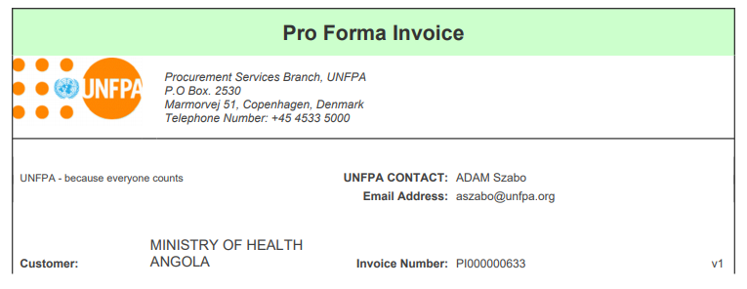
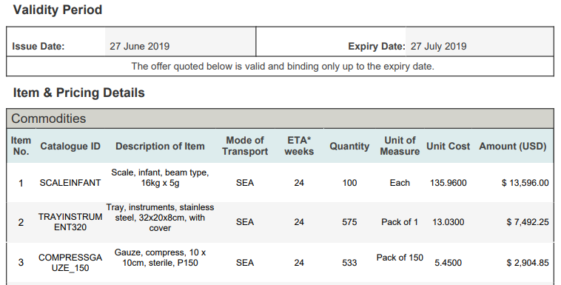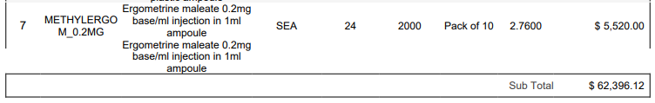
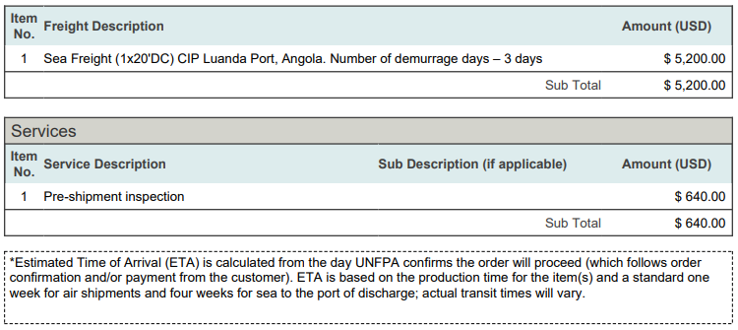
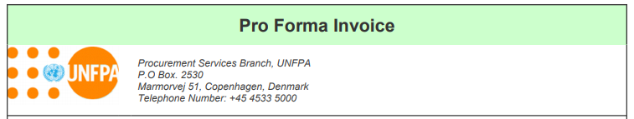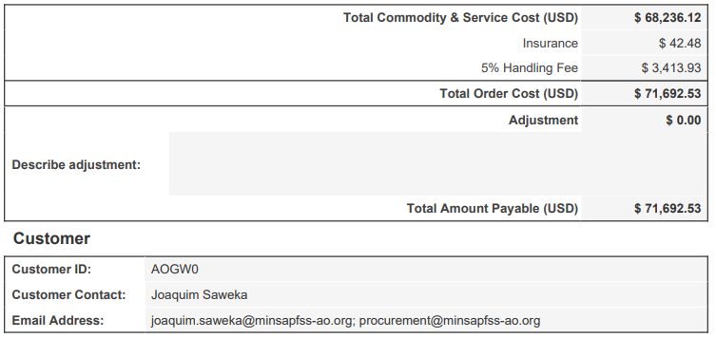
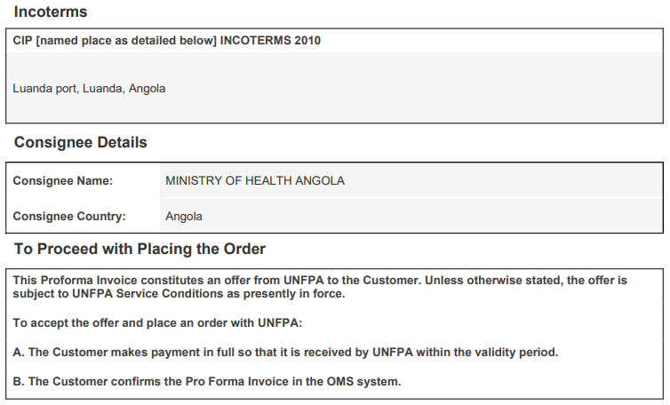
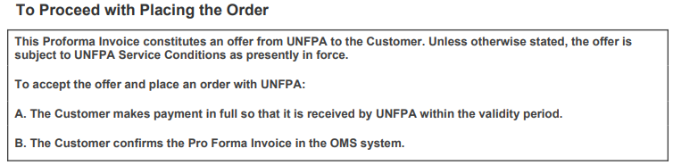

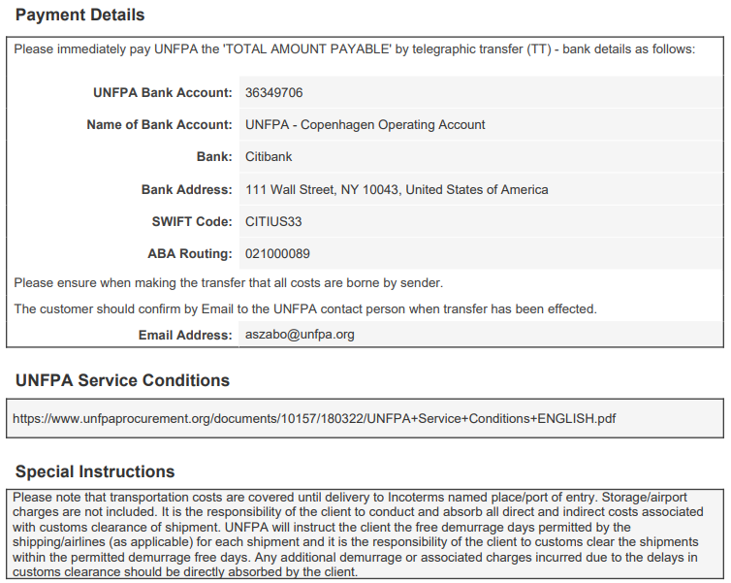
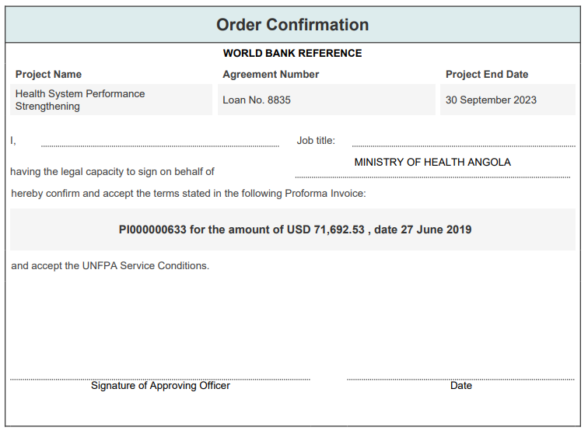

ANNEX V
PAYMENT INFORMATION

1. Payment information is provided in the Pro Forma Invoice.

2. Instructions for authorizing electronic payments
- The Chief Procurement Services Branch (PSB) of UNFPA (Copenhagen) has authorized the following staff of UNFPA to submit electronic payment requests (disbursement requests):
Authorised UNFPA Staff 1  Name: [__________________]  Title: [__________________]  Date: [date/month (in words)/year] | Authorised UNFPA Staff 2  Name: [__________________]  Title: [__________________]  Date: [date/month (in words)/year]

- For Government users:
- Upon each Order Confirmation, the Government will submit to the Bank an application for issuance of a UN commitment, bearing the names of the two UNFPA staff who are authorized to submit payment requests through the Bank’s online disbursements system (Client Connection). The application shall be in the amount stated in the Order Confirmation.

- When preparing the application for issuance of a UN Commitment, the Government shall ensure that:

  - the UNFPA bank account and payment details provided in Client Connection match the payment instructions and details included in Pro Forma invoice;
  - The names and details of the two authorized UNFPA staff stated in the above authorization signature box are the same as in the application for a UN commitment.

- The UN commitment issuance application shall be submitted by the authorized government signatories for the Project, through Client Connection that is already established for the Project and in accordance with the standard Disbursement Guidelines, and the Disbursement and Financial Information Letter to the Government. The World Bank will then send a UN commitment letter to UNFPA, specifying the terms and conditions of the issued UN commitment.

- For UNFPA users:

- The Bank will process the request for issuing the UN commitment submitted by the Government after conducting regular due diligence, which includes the Bank’s Task Team Leader (TTL) clearance.

- Once the UN Commitment issuance request is approved by the Bank, the designated UNFPA staff will receive a notification of registration in Client Connection with specific instructions on how to access the system. The designated staff would then be able to log in to the Client Connection and submit payment requests. The Bank’s Client Connection system is secured by two-factor authentication using a password and PIN.

- Upon receipt of the payment request from UNFPA, the Bank will conduct its regular due diligence, which includes clearance by the TTL, and will process the payment to UNFPA.

- Upon completion of procurement and delivery of Supplies, UNFPA will upload the funds utilization report in the format provided in Annex VII, through the Client Connection system.
ANNEX VI
TEMPLATE FOR ACCEPTANCE DOCUMENT
[to be prepared by the Government upon receipt of the shipment]

Date: [ ]
Attention: UNFPA
Cc: International Development Association

Reference: [insert Project Name, Loan/Credit/Grant number, Agreement Reference Number (as per Project’s Procurement Plan]

This Notice confirms receipt of the following Supplies:
Pro Forma Invoice No. [same as in the Pro Forma Invoice related to this shipment]
Airway Bill No.………….

Date the order arrived at the delivery destination (DD/MM/YY): ………….
Shipment quality (check one):
- Goods fully received in good order
- Goods missing
- Goods damaged

Comments (optional) ……………………………………………………………………………..
…………………………………………………………………………………………………….

__________________________
Name

__________________________
Title

__________________________
Location (City, Country)
ANNEX VII

REPORTING TEMPLATE

(UNFPA letterhead)

Cumulative Summary of Completed and Pending Procurement Actions as of [insert the date]

World Bank References:

Project Name: _________________________
Loan/Credit/Grant Number: ______________
Agreement Ref. Number: ________________
Total Funding Ceiling: __________________
Financing Agreement Closing Date:

- Completed Procurement Actions:
  - Pro Forma Invoice #__________, dated____; Amount in USD; Date of Funds received by UNFPA; Date of acceptance (upon completion of shipment)

  - Pro Forma Invoice #______________; Amount in USD; Date of Funds received by UNFPA; Date of acceptance (upon completion of shipment)
  - ………………………………………….
Sub-Total for (I):___________

- Pending Procurement Actions:
  - Pro Forma Invoice #_____________, dated ___________; Amount in USD; Date of Funds received by UNFPA; Date of acceptance (upon completion of shipment)

  - Pro Forma Invoice #_______, dated_______; Amount in USD; Date of Funds received by UNFPA; Date of acceptance (upon completion of shipment)

  - Request for Quotation received…….. [date] in the amount of [USD.…………]

Sub-Total for (II):___________

Total Disbursements and Commitments: [sum of Sub-Total I and Sub-Total II]

Budget Balance: [Total Funding Ceiling minus Total Disbursements and Commitments]

References in this Agreement to the “World Bank” or “Bank” include both the International Bank for Reconstruction and Development (IBRD) and the International Development Association (IDA).
Those procurement rules referred to in the World Bank’s Financing Agreement.
[Note to Users: “Project Name” refers to the project title as stated in the legal agreement (Financing Agreement) between the World Bank and the Government. It should not be confused with the name of the UN Agency’s project or program financed from other sources.]
[Note to Users: “Project Closing Date” is stated in the Financing Agreement between the Bank and the Government.]
[Note to Users: “Financing Agreement” is a legal agreement between the World Bank and the Government.]
[The Basic Agreement can be, for example, (i) the agreement (by exchange of letters or otherwise) between UNFPA and the Government, providing that the Standard Basic Assistance Agreement concluded between the UNDP and the Government applies mutatis mutandis to UNFPA; (ii) the agreement (by exchange of letters or otherwise) between UNFPA and the Government, providing that the Special Fund Agreement concluded between the UN Special Fund and the Government applies mutatis mutandis to UNFPA; (iii) the Country Programme Action Plan concluded between UNFPA and the Government, which provides that the [Standard Basic Assistance Agreement concluded between the UNDP and the Government]OR[the model Standard Basic Assistance Agreement]OR[the Special Fund Agreement concluded between the UN Special Fund and the Government] applies mutatis mutandis to UNFPA; (iv) or any other applicable document. Should the UNFPA office/unit using this standard form of agreement be unsure as to the legal basis of relationship in any particular case, please contact UNFPA’s Legal Unit, Office of the Executive Director, UNFPA Headquarters, for the exact information.]
References in this Agreement to the “World Bank” or “Bank” include both the International Bank for Reconstruction and Development (IBRD) and the International Development Association (IDA).
For UNFPA the term “purchase order” as used in this Agreement refers to the Procurement Services Contract as defined in the UNFPA service conditions
UNFPA service conditions for the procurement of supplies and services by UNFPA at the request and on behalf of customers, as from time to time amended, revised or updated, are published at http://www.unfpa.org/resources/service-conditions, or at such other URL as UNFPA may from time to time decide.
To be enforceable, this Agreement must be co-signed by the Chief, Procurement Services Branch, UNFPA. The contact information for UNFPA’s Chief, Procurement Services Branch, is as follows: UN City, Marmorvej 51, DK-2100 Copenhagen Ø, Denmark, procurement.services@unfpa.org; +45 45337220.
For UNFPA, the term “purchase order” as used in this Agreement refers to the Procurement Services Contract as defined in the UNFPA service conditions.
www.unfpaprocurement.org.
The Government can access the UNFPA annual audit reports on www.unfpa.org
Note: Contingency amount is used only to calculate the Total Funding Ceiling. No contingency is used in individual Pro Forma Invoices, which state firm price quotes.

