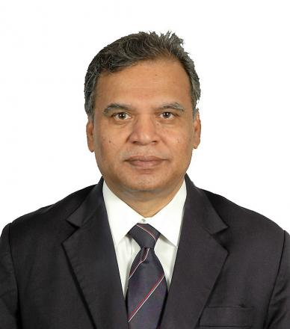 | Dr. A.R. Subbiah, Director, Regional Integrated Multi-Hazard Early Warning Systems (RIMES) Program Unit  Dr. Subbiah has operational responsibility for RIMES Program Unit and Regional Early Warning Center. He provides strategic direction and leadership for translation of policies, established by the RIMES Council, into effective and high-quality programs and services that meet RIMES Member State needs and demands. Subbiah has 35 years of experience in drought mitigation and management, and more than 15 years of experience in establishing multi-institutional and multi-disciplinary mechanisms and building institutional capacities for generation and application of climate information at different timescales.  Dr. Subbiah served as Reviewer of the IPCC Special Report on Managing Risks of Extreme Events and Disasters to Advance Climate Change Adaptation (SREX). Subbiah held senior positions with the Government of India, involved in policy formulation and implementation of development and disaster risk reduction programs till the late 1990s. Subsequently, Subbiah held the post of Director, Climate Risk Management and Team Leader for Early Warning Systems at Asian Disaster Preparedness Center and evolved and implemented a multi-country Climate Risk Management program and regional multi-hazard project that eventually transformed into RIMES as an inter-governmental and international institution in 2009.
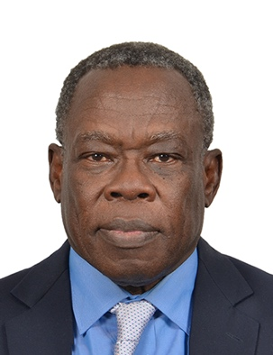 | Mr. Abdoulaye Harou, Chief, Data Processing and Forecasting Systems, World Meteorological Organization (WMO)  Mr. Harou is the Chief of Data-Processing and Forecasting System Division of the World Meteorological Organization (WMO) within the Department of Weather and Disaster Risk Reduction and Services (WDS). He coordinates activities of Global Data-processing and Forecasting Systems of WMO, is responsible for the implementation of the WMO flagship Severe Weather Forecasting Demonstration Project (SWFDPs) and act as the WMO liaison officer with the International Atomic Energy Agency (IAEA) and with the Preparatory Commission for the Comprehensive Nuclear-Test Ban Treaty Organization (CTBTO). Abdoulaye has recently taken up the responsibility for WMO technical assistance to the Department of Meteorology and Hydrology of Myanmar through an Agreement between Myanmar and WMO. This is related to the World Bank funded Ayeyarwady Integrated River Basin Management (AIRBM) Project.  Prior to taking on the challenges of the job at WMO, he held the position of Director of Aviation and Defense Weather Services, within the Meteorological Service of Canada (MSC), providing meteorological support to all three elements of the Canadian Forces (Air, Land and Sea) including training of Military Meteorological Technicians. He joined Environment Canada Meteorological Service in 1982 where he was trained as operational forecaster and forecasted for various locations including the Arctic. He has also worked as project officer with the Canadian military and subsequently trained as military officer and posted to Germany with the  Canadian NATO Forces, as senior Meteorological Officer.  Abdoulaye was born and raised in the Republic of Chad and holds a University Science Diploma, a Bachelor of Science in Physique, Master’s degrees in Atmospheric science (atmospheric modelling) and in Agricultural meteorology.
Mr. Abdul Muhsin Ramiz, Director, Meteorological Services, Maldives

Mr. Rahmiz started his career as a civil servant in 1978. He joined the meteorological service in the late 1980 and worked in the different areas such as Meteorological Observation, Weather prediction, Climate and Air Pollution. After working in Weather Forecasting field for 15 years, he was appointed the Head of the Climate Section for two years and worked as Meteorologist for about 4 years. He also managed the Air Pollution section for three years, and also worked as the head of the Marine Meteorology and Physical Oceanography Section of the Service.

Mr. Ramiz started working as Director in the Department of Meteorology in 2007. He was appointed as Director of Meteorology in 2014 and serves as member of Technical Committee on Early Warning and Emergency Communications formed after 2004 Tsunami within the Communication Authority of Maldives, to formulate a plan towards establishing an effective dissemination of multi-hazard early warnings and emergency communication system to be utilized during all the phases of disaster management, from February 2006. Mr. Ramiz also worked the Maldives Meteorological Service (MMS) in the technical committee and Resilient Island Planning in Ministry of Housing Environment in 2013 as well as Maldives Meteorological Service in the Technical Committee of National Disaster Management Center till 2017.

Mr. Abhishek Modi, Partnerships Development Manager, Google Asia

Mr. Modi is the partnership development manager at Google Asia. He has been with Google for over 5 years and is based out of Singapore. Before Google, Abhishek worked in management consulting and has co-founded 2 startups. He also once sailed around the world for 4 months covering 14 countries across 4 continents.

He holds a master’s and bachelor’s degree in Material Science from Indian Institute of Technology.

Ms. Alice Soares, International Advisor, SAHF

Ms. Soares started her career in meteorology and oceanography in 1995 at the Portuguese Meteorological Service, wherein she had held the positions of weather forecaster, marine and aeronautical meteorologist, and senior numerical weather and ocean prediction specialist. At the same time, she was awarded a visiting Professorship at the University Lusofona in Lisbon, Portugal. In 2006, Ms. Soares was appointed Scientific Officer at the Marine Meteorology and Oceanography Programme of the World Meteorological Organization (WMO); and in 2010, she was awarded a permanent position as Senior Scientific Officer at the Global Data-processing and Forecasting System Programme of WMO. She co-led the development and implementation of the WMO Severe Weather Forecasting Demonstration Project in Africa, Asia, South America and the Pacific; and created of the concept of the WMO Coastal Inundation Forecasting Demonstration Project. She was responsible for keeping up-to-date the WMO technical regulation related to data-processing and forecasting systems, and WMO technical guidelines. Since 2018, she provides expert assistance and advice on weather, water, climate and environmental-related aspects to the World Bank, and the Government of Myanmar.

Ms. Soares has authored more than 100 research papers, books, and regulatory and technical publications on meteorology (weather and climate) and oceanography. Her most recent publications include a Policy Note on Strengthening the Regional Dimension of Hydromet Services in Southeast Asia, with a focus on Cambodia, Lao PDR and Vietnam; and co-authored with World Bank colleagues, a Guide on How to Improve Hydromet Services in Developing Countries.

Ms. Archana Shukla, Senior Programme Manager, Asia Regional Team, Department for international Development (DFID), United Kingdom

Ms. Shukla is a Senior Programme Manager with the Department for International Development (DFID), which leads the UK’s work to end extreme poverty. DFID is tackling the global challenges of our time including poverty and disease, mass migration, insecurity and conflict.

Ms. Shukla is currently working in the Asia Regional Team, based in New Delhi and is the responsible for the “Asia Regional Resilience in Changing Climate” (ARRCC) programme which emphases to help vulnerable people in Asia become more resilient to the impacts of a changing climate and protect economic growth. Besides ARRCC, she is also managing other climate resilience programmes for urban poor and climate proofing for growth diagnostic.

She comes with more than two decades of varied experience in Climate programmes, Public Procurement and Finance. She brings along with her affluent skill of strategic project management gained from working in both Public and Private Sector for the UK & Asia region.

Ms. Arati Belle, Disaster Risk Management Specialist, World Bank

Ms. Belle is in the World Bank’s South Asia Climate Change and Disaster Risk Management Unit and leads Hydromet and disaster resilience investment projects and technical assistance activities in Afghanistan, Bangladesh and Bhutan. Additionally, she is the Regional Coordinator of the World Bank’s program on Hydromet, Early Warning and Climate Services for South Asia. Ms. Belle brings over 16 years of operational experience in the World Bank, GEF and Adaptation Fund, with technical expertise in the areas of climate resilience, disaster risk reduction, and environmental sustainability. In addition to South Asia, Ms. Belle has led and worked on climate information, environment and disaster resilience related operations in the Africa and Latin America and Caribbean regions.

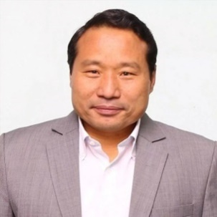 | Honorable Mr. Barshaman Pun ‘Ananta’, Minister of Energy, Water Resources and Irrigation, Nepal  Mr. Pun is the Minister for Energy, Water Resource and Irrigation for the Government of Nepal. Mr. Pun is an elected member of Parliament from Rolpa. He is a Standing Committee Member of Nepal Communist Party. He has also previously held minister portfolios in the Ministry of Finance (August 2011-March 2013) and Ministry for Peace and Reconstruction (February 2011-April 2011). Mr. Pun has obtained a bachelor’s degree in Law from Tribhuvan University, Nepal.
Mr. Christoph Pusch, Practice Manager, World Bank

Mr. Pusch is the Practice Manager at the World Bank Group for a current US$4.4 billion investment portfolio on climate and disaster resilience in the South Asia region. This includes a wide range of activities such as large scale reconstruction and recovery programs after major earthquake, floods, and cyclone events in Bangladesh, India, Nepal, and Pakistan; improved early warning systems and preparedness programs along the 10,000 km coast line in India; coastal vulnerability programs in Bangladesh; innovative risk financing instruments against natural disaster in Sri Lanka and Maldives; technical assistance program to integrate risk reduction measures in infrastructure investments in Afghanistan; modernizing Hydromet systems in Bangladesh, Bhutan, Nepal and Pakistan; advisory services to support countries in implementing their climate commitments (Nationally Determined Contributions, NDCs). In this capacity, he is overseeing a technical expert team of about 30 staff based in the South Asia countries and Washington DC. Mr. Pusch holds a master’s degree in Environmental Engineering from the Technical University of Berlin.

David Corbelli, Senior International Development Manager, UK Met

Mr. Corbelli is a Senior International Development Manager at the UK Met Office specializing in the development and implementation of weather and climate services with extensive experience of delivering several programmes and projects across Asia. He is currently responsible for leading the UK Department for International Development (DFID) funded Asia Regional Resilience to a Changing Climate (ARRCC) Met Office Partnership Programme in South Asia and played a key role in leading the regional stakeholder consultation and evidence review to support the business case for ARRCC prior to the programme’ s inception in 2018.

Responsible for overseeing Met Office activities in Asia, he has previously led a number of weather and climate initiatives including the World Bank funded “International review of trans-boundary early warning systems”, Asian Development Bank “Institutional review to inform modernization of Tajikistan Hydromet service” and the DFID funded project “Building capacity to improve resilience to weather and climate extremes in the Philippines”.

Prior to the Met Office, David has worked as policy manager for both the UK Department for Energy and Climate Change and UK Environment Agency and has a strong background in climate mitigation and adaptation with experience of working with a wide range of sectors including water, energy, health, agriculture, waste and transport to support carbon reduction measures and development of adaptation approaches. As an experienced environmental scientist David has technical expertise in weather and climate services, integrated river basin management and development of ecosystem services.

Dr. David Rogers, International Advisor, SAHF

Dr. Rogers in an International Advisor providing technical expertise to Hydromet modernization efforts in South Asia. His career in meteorology and oceanography spans nearly four decades. He has authored over 100 papers and books on meteorological and oceanographic research including marine atmospheric boundary layer processes, cloud physics, numerical model parameterization and policy. His most recent publication, co-authored with World Bank colleagues, is a guide on how to strengthen National Meteorological and Hydrological Services in a time of considerable technological change, advances in private sector services and the growing threat of weather, climate and hydrological extremes.

He has held numerous senior appointments including Chief Executive of the
UK Met Office, Vice President of Science Applications International Corporation, Director of the Office of Weather and Air Quality Research at the National Oceanic and Atmospheric Administration, Director of Physical Oceanography at Scripps Institution of Oceanography, Associate Director of the California Space Institute and President of the Health and Climate Foundation, which he co-founded. He is current a senior advisor to the World Bank and Global Facility for Disaster Risk Reduction on weather, climate and hydrological issues.

Ms. Donna Lagdameo, Senior Policy Adviser and Asia Pacific Regional Focal Point, Red Cross Red Crescent Climate Center

In 2013, Donna joined the Climate Centre and since then, has been providing policy-related technical support on climate change adaptation (CCA), disaster risk reduction (DRR) and resilience building to the Red Cross Red Crescent movement and partners in the Asia Pacific region. She is engaged in local climate change planning; mainstreaming in local development plans as well as in national planning processes and policy development – making sure that the needs of the most vulnerable are identified, reflected and addressed at all levels.

Donna is the Asia Pacific regional lead for the Climate Centre and is actively engaged in various platforms and processes to link science and practice into policies, plans and budgets and ensure that climate-smart policies are operationalized on the ground. As the senior policy advisor, she represents the Red Cross Red Crescent Movement in various processes within the UNFCCC, including Loss and Damage, Adaptation, Local Communities and Indigenous People’s Platform, and in discussions with the Green Climate Fund. For almost 25 years, Donna has been specializing in policy research and development, governance, advocacy and knowledge management work in DRR, CCA, resilience and risk-informed development. She has work experiences in the legislative and executive branches of government; international NGOs; regional and UN bodies; and in the Red Cross Red Crescent family.

Donna is based in Manila, married and has 4 daughters.

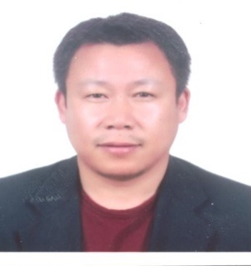 | Mr. Dorji Gyeltshen, Chief Engineer, Bhutan Department of Roads  Mr. Gyeltshen has been an engineer in the Department of Roads in Bhutan for the last eighteen years, and currently working as Chief Engineer of Maintenance Division. He has worked on many road projects in Bhutan in all kinds of aspects including planning, design, construction management, and maintenance. He also worked as Assistant Project Coordinator for the World Bank Funded Rural Access Project and Project Coordinator for Government of India Funded Projects.
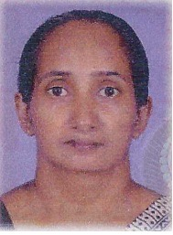 | Ms. Dulari Gangani Fernando, Deputy Director, Department of Meteorology, Sri Lanka  Ms. Fernando is a Deputy Director of Department of Meteorology, who is the Administrator of Regional Meteorological offices, Rainfall, Climate & Data Divisions. She is also a supervisor of the Meteorological observation networks including maintenance and upgrading observation equipment in Sri Lanka.  Before assuming duties as a Deputy Director, Dulari worked 12 years as a forecaster for National Meteorological Center (NMC) and International Airports. She has a bachelor’s degree in Mathematics and Postgraduate diploma in Satellite Meteorology and Global Climate.
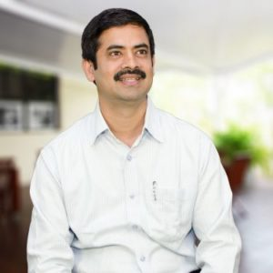 | Dr. Giriraj Amarnath, Research Group Leader, Water Risk and Disasters (WRD), International Water Management Institute (IWMI)  Dr. Giriraj is the research group leader of Water Risk and Disasters (WRD) at the International Water Management Institute (IWMI). He has over 13 years’ experience in research including 3 years in academic at University of Bayreuth, Germany.  Dr. Giriraj has conducted research on the: (i) mapping flood inundation extent in south Asia and south-east Asia, (ii) global flood hotspots assessment for climate risk studies, (iii) piloting operational flood mapping and modeling in Eastern Sudan, (iv) snow cover mapping and monitoring in the Hindu-Kush Himalayas, (v) vegetation cover change and biodiversity assessment in Western Ghats (India), Sagarmatha National Park (Nepal), (vi) species niche modeling for endangered plants species in Western Ghats (India), (vii) environmental impact assessment using RS/GIS and (viii) relationship between upstream-downstream linkages in Indo-Gangetic plain and the possible causes of climate change impacts in this region. Giriraj’s academic and professional work have given him substantial experience including time living and working in India, Nepal, Germany, South Asia, Southeast Asia and Eastern Africa.
Mr. Hartwig Schafer, Vice President, South Asia Region, World Bank

Mr. Schafer became the World Bank’s Vice President for the South Asia Region on July 1, 2018.
In managing the World Bank’s engagement in South Asia to end extreme poverty and boost shared prosperity, Schafer leads relations with Afghanistan, Bangladesh, Bhutan, India, Maldives, Nepal, Pakistan, and Sri Lanka. He manages a portfolio of financial support worth more than $50 billion.
Before joining the region, Schafer served as the Vice President for Global Themes where he oversaw the World Bank Group’s engagement in corporate priority areas of Fragility, Conflict and Violence, Gender, Infrastructure, Public-Private Partnerships, Guarantees, Climate Change, and Knowledge Management.
In his previous role as Vice President for Operations Policy and Country Services, Schafer was responsible for the World Bank’s business policies, practices, and procedures for lending products and knowledge services to client countries. He led several key reforms, including the rollout of the Bank’s new policies on procurement, environmental and social safeguards, and innovation of the Bank’s lending and knowledge instruments.
Previously, Schafer served as the World Bank’s Country Director for Djibouti, Egypt, and Yemen in the Middle East and North Africa Region. He was Director for Strategy and Operations in the Sustainable Development Network. Schafer has also worked as Director for Operations and Strategy in the Africa Region, Country Director for Malawi, Zambia and Zimbabwe and Chief Administrative Officer in the Africa Region.
A German national, Schafer has held technical and managerial positions in the World Bank as well as the European Commission for almost 30 years. He brings strong operational experience from several regions and sectors. His academic background is in Economics (Ph.D.) and Agricultural Economics.
Mr. Imran Jamil Shami, Joint Secretary, Pakistan Aviation Division

Mr. Shami has been serving on various positions in the civil bureaucracy of Government of Pakistan since last 30 years. Presently, he is posted as Joint Secretary in the Federal Ministry of Aviation since 23 February 2019 and supervising the affairs of Pakistan Meteorological Department, Airports Security Force and all the Development Projects pertaining to these departments as well as the Pakistan Civil Aviation Authority. Being an officer who seamlessly envision and deliver, Mr. Shami has been able to launch new initiatives through the Pakistan Meteorological Department for the real benefit of its services to the Agriculture, Tourism and Aviation sectors of the country and for the masses as well.
Mr. Shami has master’s in business administration and Post Graduate Certificate from Royal Holloway University of London,

Mr. Jim Anderson, Chairperson, Hydro-Meteorological Equipment Industry (HMEI)

Mr. Anderson was elected Chair of the Hydro-Meteorological Equipment Industry at its Twenty-first General Assembly meeting held during the Eighteenth World Meteorological Congress in June of 2019.Mr. Anderson is the Senior Vice President of Global Sales at Earth Networks. He is focused on the international and domestic expansion of the company and meeting the weather and environmental monitoring needs for several vertical market stakeholders, including government agencies, agriculture, energy and transportation. Mr. Anderson joined the company in 2002 and led the launch business efforts in the energy, public safety, federal government and commercial verticals.

Previously, Mr. Anderson was a principle consultant at American Management Systems, where he helped launch the energy and utilities practice. Prior to that, he conducted economic and public policy research in the agriculture and environmental sectors.

Mr. Anderson holds an MBA from Georgetown University, a Master of Science in environmental economics and policy from the University of Maine, and a Bachelor of Science in biology and economics from the University of Wisconsin–Madison.

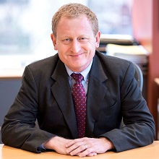 | Mr. John Roome, Regional Director, South Asia Sustainable Development, World Bank  Mr. Roome is Regional Director, South Asia Sustainable Development at the World Bank. Before that he was the Senior Director leading the World Bank’s work on Climate Change from 2015 to 2019. John joined the World Bank in 1989, working initially in Africa. He has since held various leadership positions including Director for Sustainable Development in the Bank’s East Asia and the Pacific Region, Operations and Strategy Director in the Bank’s South Asia region and as Operational Quality Director in the Bank’s Africa region. His Bank experience spans water, urban, transport, energy, rural, agriculture, environment, and social sectors, as well as disaster risk management and climate change.  Before joining the World Bank, John worked in Europe for Monitor Company, a leading corporate strategy consulting firm, and at Old Mutual, a South African Life Assurance Company. He was educated at Oxford University, as a Rhodes Scholar, where he obtained Master’s Degrees in Econometrics and in Management Studies, and at the University of Cape Town where he obtained a Bachelor’s degree in Economics, Statistics and Actuarial Science. He is married with three children and enjoys running, biking, hiking and kayaking.
Mr. Karan Agarwal, Partnership Development Manager, Google India

Karan Agarwal works as a Partnership Development manager at Google India. He has been with Google for over a year and is based out of Gurgaon. Before Google, Karan has worked Rivigo (tech-enabled logistics company) and Airtel Payments Bank across multiple areas including product management, partnerships, and strategic planning. He holds a Master’s degree in Finance from Institute of Management Technology (IMT), Ghaziabad
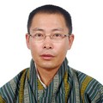 | Mr. Karma Dupchu, Director, National Center for Hydrology and Meteorology (NCHM), Bhutan  Mr. Dupchu is the Director of National Centre for Hydrology and Meteorology (NHCM) that is responsible for weather, climate, cryosphere, hydrology and water resources in Bhutan. He is the Permanent Representative of Bhutan with WMO. Prior to this position, Mr. Dupchu was the Chief of the Hydrology and Water Resources Services Division, NCHM. During his more than 20+ years in the services of National Meteorological and Hydrological Service (NMHS), he has contributed to institutional restructuring of NMHS and modernization of hydro-meteorological network and services in Bhutan. One of his most notable contribution in the field of DRM in Bhutan is the installation of first automatic GLOF Early Warning System along the Punakha-Wangdi valley in Bhutan (2009-2013), followed by Rainstorm/GLOF Early Warning System in the Mangdechhu and Chamkharchu sub-basins in 2013-2016 as the Project Manager.
Dr. Laxman Singh Rathore, International Advisor, SAHF
Dr. Laxman Singh Rathore is former Director General of Meteorology, India Meteorological Department (IMD), Ministry of Earth Sciences. He was Permanent Representative of India with the World Meteorological Organization (WMO) and served many international bodies, in various capacities such as Chair, Inter-governmental Board for Climate Services (IBCS), WMO, United Nations; Member of WMO Executive council; Vice President, Commission for Agriculture Meteorology, WMO; Chairman, Governing Council of SAARC Meteorological Research Centre, Dhaka etc.

He made significant contribution towards improving the weather forecasting, particularly cyclone, extreme weather events and development of Agro-meteorological Advisory Service in India.

He has published more than 100 research papers, wrote 11 books and 41 book chapters and participated in 3rd Indian Scientific Expedition to Antarctica. He has supervised 5 Ph.D. students through extramural research from reputed institution such as Indian Institute of Technology, Delhi; Guru Jambheshwar University, Hisar; Andhra University, Vishakhapattanam and Banares Hindu University, Varanasi. He is Fellow of Indian Meteorological Society and Honorary Fellow of Association of Agro-Meteorologists and recipient of over a dozen national awards.

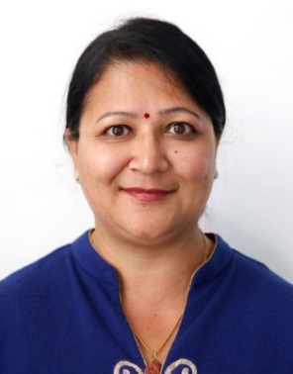 | Dr. Mandira Shrestha, Programme Coordinator: Climate Services and Hi-RISK initiatives, ICIMOD  Dr. Shrestha is a Programme Coordinator of Hi-RISK initiative at ICIMOD. She has over 20 years of research and consulting activities that cover broad areas of climate services, water induced disaster risk reduction and water resources management. She is leading the transboundary flood risk reduction programmes, promoting dialogue and strengthening Hydromet capacity in the region. Her research interests center on transboundary flood forecasting and monitoring, application of satellite-based products and end user engagement for reduced flood risks. Her current research focuses on communicating flood early warning to improve the last mile connectivity. She has coordinated the development of a web based regional flood information system in the Himalayan region where the countries are sharing real-time data and information for flood risk reduction thereby strengthening regional cooperation. She served as the Executive Secretary of HKH-FRIEND, an IHP/UNESCO programme and coordinated all activities with international and regional collaborating institutions.  Dr. Shrestha holds a Doctorate in Engineering from Kyoto University, Japan, an MSc in Civil Engineering from the University of Washington, Seattle, USA, and a Bachelor’s on Civil Engineering from the University of Roorkee (now IIT Roorkee). Dr. Shrestha has an excellent professional network with donor agencies and partner organizations in the region.
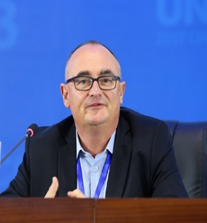 | Mr. Markus Repnik, Director of Development Partnerships, the World Meteorological Organization (WMO)  Markus Repnik is an international development executive with 30 years of experience gained with the United Nations, World Bank Group, Austrian Government, NGOs and private sector, including 16 years field experience in developing and transition countries. Since October 2017 he is Director of Development Partnerships at the WMO, leading a team that creates innovative mechanisms for increased and more effective Hydromet support to WMO developing country Members.  Prior to joining WMO Mr. Repnik was Managing Director of the Global Mechanism, the operational arm of the United Nations Convention to Combat Desertification (UNCCD). Mr. Repnik worked 15 years at the World Bank Group, including 10 years as a manager. As country manager he was responsible for the Bank’s engagement with several African and European countries. Mr. Repnik holds a Master of Economics and Social Sciences.
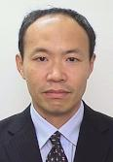 | Mr. Masatsugu Takamatsu, Disaster Risk Management Specialist, World Bank  Masatsugu Takamatsu is a Disaster Risk Management Specialist in the Disaster Risk Management & Climate Change (DRM&CC) Unit for South Asia Region. He holds Bachelor and Master’s degrees in environmental engineering from Kyoto University, Japan and PhD degree in Environmental and Water Resources Engineering from University of Texas at Austin, USA.  Masatsugu worked for a civil engineering design firm in the USA for more than 10 years as a water resources engineer and has Professional Engineer license from the State of Maryland. At the World Bank, he currently manages a GFDRR-EU Trust Fund Program on Building Resilience to Geohazard Risks in South Asia as a Task Team Leader. He also supports various flood-related projects in the South Asia Region.
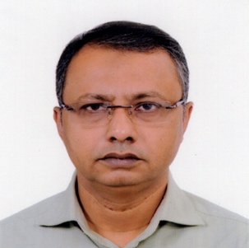 | Mr. Mazharul Aziz, Project Director, Department of Agricultural Extension, Bangladesh  Dr. Aziz is Project Director for Agro-Meteorological Information Systems, Development Project, Department of Agricultural Extension, Ministry of Agriculture, Bangladesh. With graduation in Agriculture, Master of Science in Agronomy and PhD in Crop Botany, Dr. Aziz has over 24 years of experience in agricultural extension services.  Areas of expertise include: (1) technology dissemination; (2) climate change adaptation and mitigation in crop sector; (3) project formulation, implementation, monitoring and evaluation; (4) preparation of training and extension materials like Training Module, Multimedia Presentation Slide, Poster, Calendar, Leaflet etc; and (5) well experienced in networking with GO, NGO and UN Agencies.
Dr. Michael J. Ernst, Ph.D., Hydro-Meteorological Hazards Advisor, Office of Foreign Disaster Assistance (OFDA), U.S. Agency for International Development (USAID)

Michael has over twenty-two years of experience in the field of disaster risk reduction (especially early warning and preparedness systems), humanitarian assistance, and international development, working in association with the Office of U.S. Foreign Disaster Assistance (OFDA) for half of those years.

Four years ago, Michael served as Disaster Assistance Response Team (DART) Deputy on the Nepal Earthquake Response. He has also supported humanitarian assistance efforts for the West Africa Ebola epidemic, floods and landslides in Uttarakhand, and Cyclone Phailin in Odisha, India. Michael also has extensive experience working with the United Nations Development Program (UNDP) and other UN System Agencies on disaster risk reduction and recovery issues in Asia, including early recovery efforts for the Indian Ocean Tsunami of 2005, Pakistan Floods of 2010, and the Indonesia Merapi Volcano and Mentawai Tsunami.

Michael has a Ph.D. from the Massachusetts Institute of Technology in Civil and Environmental Engineering with a water resource system focus.

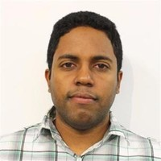 | Dr. Michael Souffront, Software Engineer/Water Resources, Aquaveo  Dr. Souffront specializes in modeling workflows and in developing data visualization solutions including web and mobile applications. He has published various scientific articles on hydrologic data management and visualization. Born in the Dominican Republic and based in Utah, USA, Michael obtained a Master’s degree in Watershed Sciences at Utah State University, and a PhD in Civil and Environmental Engineering with a focus in Hydro informatics from Brigham Young University. He is currently the lead Global Streamflow Prediction System (GSPS) developer and a Tethys platform developer for Aquaveo, where his research contributes to a new hydrologic modeling approach that takes advantage of the latest advances in information technology and cloud computing to provide hydrologic modeling as a service (HMaaS). Dr. Souffront is leading the current efforts to disseminate this new approach in collaboration with organizations that  include the World Bank and GEOGloWS.  Michael and his wife Jolyn are the parents of three beautiful children. When he is not working, he enjoys playing guitar, reading, writing, and playing board games.
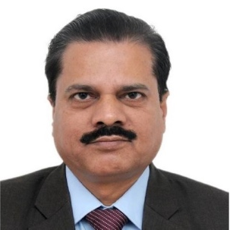 | Dr. Mrutyunjay Mohapatra, Director General, India Meteorological Department (IMD)  Dr. Mrutyunjay Mohapatra is currently the Director General of Meteorology, India Meteorological Department since 1st August 2019. He is the Permanent Representative of India with WMO with effect from 10th June 2019. He has been elected as Member of Executive Council, WMO for the period 2019-23 with effect from 13th June.  With a Ph. D in Physics and 26 years of experience in meteorology, he has made significant contributions in improvement of early warning services of IMD. He has brought laurels to the country from various international agencies like United Nations, World Meteorological Organization for effective early warning, especially for cyclones. To mention a few are the timely and accurate warnings for cyclone, Phailin, Hudhud, Vardah, Titli, Sagar, Mekunu and Fani in recent years. His brilliance and expertise in cyclone warning has helped in better management of cyclones leading to minimum loss of human lives. He is popularly known as “The Cyclone Man of India”.  He is the author of more than 75 research papers published in peer reviewed national and international journals. He has edited 3 books and 7 Journals.
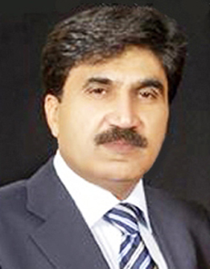 | Dr. Muhammad Hanif, Chief Meteorologist/Project Director, Pakistan Meteorological Department (PMD)  With over 24 years of professional experience in the field of Operational Meteorological and Hydrology, Dr. Hanif has a wide range of experience in programmes and initiatives regarding climate change impacts, climate change adaptation, climate resilience, agro-met services, disaster risk reduction, effective early warning systems and public weather services for stakeholders and the vulnerable communities at national and regional levels.  He has presented Pakistan in several international seminars, conferences and workshops and contributed in the development of many international and regional programmes related to weather and climate services. He has also developed some projects regarding early warning systems and disaster risk reduction in Pakistan. Recently with support of WMO, HRC and USAID, Dr. Hanif has actively contributed in the development of Regional Flash Flood Guidance System for South Asia. Dr. Hanif holds PhD in Seasonal and Climate Predictability from University of Liverpool, UK, MSc in Physics from Islamia University Bahawalpur, and BSc in Physics and Mathematics from University of Punjab, Pakistan
Mr. Naresh Man Shakya, Senior Divisional Engineer, Department of Roads, Nepal

Mr. Naresh Man Shakya is a Senior Divisional Engineer posted currently in Bridge Branch under Department of Roads, Ministry of Physical Infrastructure and Transport, Government of Nepal. He is serving in this department for more than 27 years in various capacities. He is currently taking responsibility of coordination of Bridge Building, maintenance, development and operation of various software such as Bridge Management System, Grievance Redress System, Bridge Site Monitoring system etc. that are being used as tools for Bridges Improvement and Maintenance Program (BIMP II), funded by the World Bank under Program for Results (P4R) concept. His major involvement is in project planning including pre-appraisal, appraisal, feasibility studies; monitoring,
coordinating with various field divisions and projects under Department of Roads; liaison with development partners including World Bank and others. He has sound and proven expertise in Geotechnical engineering, geo-hazards assessment particularly in the context of slope stability analysis, landslide treatment and design of slope strengthening structures in fragile mountain slopes. He had played key role in solving the Krishnabhir landslide which is one of the biggest landslides in the history of Nepal along highways. He is fully familiar with the geotechnical environment of Nepal
and Bhutan road network.

Mr. Naresh Man Shakya achieved his first degree in Civil Engineering from Harcourt Butler Technological Institute, Kanpur, India and thereafter did his master’s in engineering Geology from the University of Newcastle upon Tyne, UK. He is a member of Engineering Association of Nepal, Nepal Geotechnical Society and Road Safety Society of Nepal.

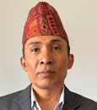 | Er. Rabindra Nath Shrestha, Secretary; Ministry of Energy, Water Resources and Irrigation  Er. Rabindra Nath Shrestha is the Secretary for Ministry of Energy, Water Resources and Irrigation. Prior to this, Mr. Shrestha worked as a Water Supply and Sanitation Engineer from 1990 AD to 2004 AD, Senior Divisional Engineer in Department of Local Infrastructure Development and  Agricultural Road 2004 AD to 2009 AD.  He has worked as a Joint Secretary in Ministry of Physical Infrastructure and Transport. His roles included Deputy Director General and Director General in the Department of Road from 2009 to 2019. He obtained his B.E. in Civil Engineering from Allahabad University, MONERECO, India and M. Sc. in Environmental Engineering from Tribhuvan University, Nepal
Mr. Ram Prasad Bhandari, Program Manager (Aid Coordination, Climate/Disaster Risk & Emergency Housing Reconstruction), JICA

Mr. Bhandari is currently working with Japan International Cooperation Agency, Nepal Office and looking after Disaster Risk Management Portfolio. Prior to joining JICA, worked with the Government of Nepal and INGO in Planning, Designing and Implementation of Irrigation and River Training Works and Hydropower Governance.

He completed B.E. in Civil Engineering from the Then University of Roorkee (Now IIT Roorkee), India in 1987 and Master’s in Water Resources Engineering from The University of Tokyo, Japan in 1997

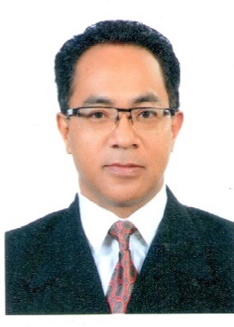 | Mr. Saraju Kumar Baidya, Director General, Department of Hydrology and Meteorology, Nepal  Mr. Saraju Kumar Baidya is currently the Director General, Department of Hydrology and Meteorology of Nepal. Prior to holding this position, he worked as Deputy Director General in Climate Division and Meteorological Forecasting Division.  Mr. Baidya is extensively involved in research activities in drought, climate change, climate variability, climate extremes, climate change adaptation and monsoon of Nepal. He also has experience in working as a technical expert in preparing “Drought Hazard Assessment of The Democratic Republic of Timor-Leste and People’s Democratic Republic of Laos” and also prepared “Drought Analysis of Nepal using Standardized Precipitation Index (SPI) and Soil Moisture Index (SMI)”  He has worked as a member in the National Adaptation Program of Action (NAPA) thematic working group “Public Health”, Nepal and is also a member in the Coordination Committee formed by the government of Nepal to formulate ‘National Climate Change Policy’. Mr. Baidya has completed his M. Sc. in Applied Meteorology from The University of Reading, UK, M. Sc. in Meteorology from Tribhuvan University, Nepal and Post Graduate Diploma in Satellite Meteorology, India
Dr. Satyagopal Korlapati, Former Tamil Nadu State Relief Commissioner, India
Dr K Satyagopal IAS Retd was appointed after retirement as Chairman and Managing Director of Tamil Nadu Water Resource Conservation and Rivers Restoration Corporation (TNSMART). The TNSMART system was conceptualized, developed and operationalized under the leadership of Dr. K. Satyagopal.
Dr. Satyagopal evolved an innovative institutional mechanism to ensure the system’s sustainability through Disaster Management policy in Tamil Nadu. He belongs to the Indian Administrative Service batch of 1987, he was previously posted as the Additional Chief Secretary/Commissioner Revenue Administration, Commissionerate of Revenue Administration & Disaster Management, Government of Tamil Nadu.
He was the State Relief Commissioner also. He has handled Vardah, Ockhi and Gaja cyclones and Incessant rains in November 2017 and the severest drought faced by Tamil Nadu during 2016-17. He was the first Director General of National Institute of Plant Health Management, Department of Agriculture & Cooperation, Ministry of Agriculture, Hyderabad. He was also founding Director Dept of Environment Government of Tamil Nadu and he was the Special Officer and first Collector of Theni District. He held important positions in Rural Development, Welfare, Industry and Finance Departments during his 32 years of service as an IAS Officer in Tamil Nadu.
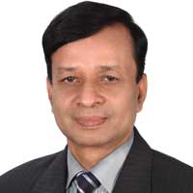 | Mr. Shamsuddin Ahmed, Director, Bangladesh Meteorological Department (BMD)  Mr. Shamsuddin Ahmed has been the Director, Bangladesh Meteorological Department since March 20, 2017. Mr. Ahmed, a Meteorological scientist, was born on 1st November 1962. Mr. Ahmed is the 1st son of Nazir Ahmed, a government official of the Government of the Peoples Republic of Bangladesh. Mr. Ahmed holds an MSc in Physics from Chittagong University. He is the Permanent Representative of Bangladesh with WMO since April 29, 2016.
Dr Stephan Siemen, Head of Development Section, Forecast Department, European Center for Medium Range Weather

Stephan Siemen heads the Development Section at ECMWF. The section develops software and services to support core activities at ECMWF. The software enables researchers and analysts in and outside ECMWF to en/decode, process, access, archive and visualize observations and forecast data.

Stephan’s background is with the visualization of meteorological data. He has a leading role in implementing new services focused on making large volume weather forecast data easily available to users. One such project is the European Weather Cloud at ECMWF. He helps to co-ordinate software developments projects across the wider meteorological community.
Dr. Vladimir Tsirkunov, Lead Specialist, GFDRR, World Bank

Dr. Vladimir Tsirkunov is a Lead specialist and the team leader of Hydromet Program of the Global Facility for Disaster Reduction and Recovery (GFDRR) of the World Bank. Since 2003 he is involved in development and implementation of investment and technical assistance projects supporting improvement of weather, climate and hydrological services and modernization of National meteorological and hydrological services.

Dr. Tsirkunov has over 40 years of scientific, applied technical and project
management experience in environmental and natural resource management. Prior to joining the World Bank in 1994, he was the Head of the Laboratory of the Supervision of the USSR (then Russia’s) System of Hydro chemical Monitoring and Water Quality Data Collection.

